An Instructional Research Handbook
for Spring Garden Elementary

Created by
Mrs. Jones
April 25, 2004

In addition to providing a wealth of literature books to read, a Media Center provides many kinds of research materials to help you answer all of those pressing questions you’ve been wondering about. Not to mention, all of the projects you need to complete for your teachers! In this booklet, you will find information about two main topics. First, you will learn which major research materials we offer. Secondly, you will learn the basics of completing a research task, using these very resources!

So, to get you started, here is a visual layout of the reference area in our Spring Garden Elementary Media Center:

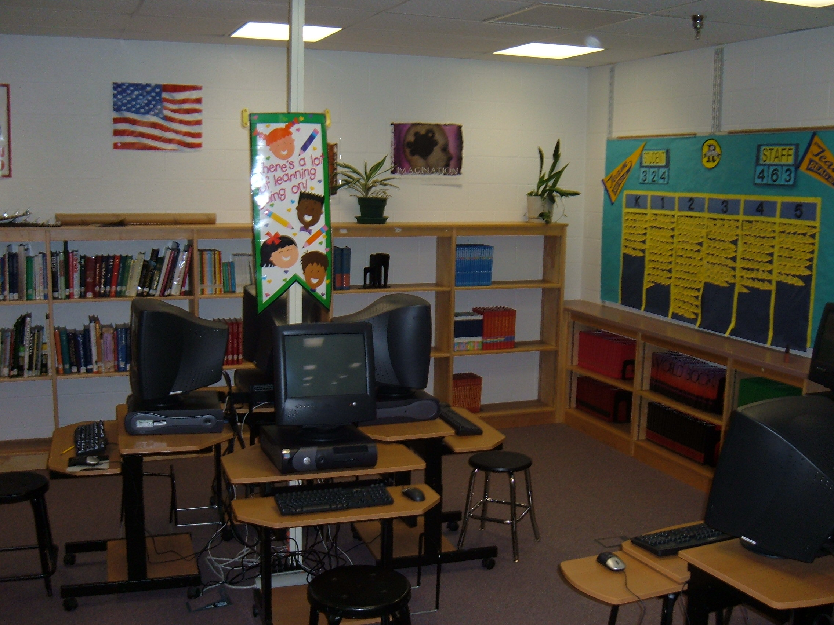

When you first walk in to the East side of the Media Center, you will find the Reference Corner immediately to your right. Here, you will find encyclopedias, atlases, dictionaries, thesauri, and many, many other helpful resources to answer your questions!

On the next page is a list of some of the general, and most helpful, research materials you will want to go to when you begin your research activity:

Annotated Bibliography of Primary Reference Materials:

Encyclopedias
(The encyclopedia is the best starting point for most projects.)

Childcraft – The How and Why Library. Chicago: World Book, Inc., 1989.

This 15-volume set is geared toward younger elementary school students. Each volume provides a combination of essays, literature, and activities. Volume headings are: Once Upon a Time, Time to Read, Stories and Poems, World and Space, About Animals, The Green Kingdom, Story of the Sea, About Us, Holidays and Birthdays, Places to Know, Make and Do, How Things Work, Mathemagic, About Me, and Guide to Childcraft. The pictures are colorful, and the text is reader-friendly.

Children’s Britannica (4th Ed.). Chicago: Encyclopedia Britannica, Inc.,1990.

This 20-volume set is written in a simple, straightforward manner that is easy for children to understand. The text is larger print and the layout is spaced well. All of the entries are cross-referenced. The illustrations are a mixture of color and black and white. There is a kid-friendly “How to Use Children’s Britannica” section at the beginning of the first volume. The index of the entire set includes over 6,000 short entries for giving instant factual information for quick answers. I would recommend looking here first for those simple answers you need.

Golden Book Encyclopedia. Racine, WI: Western Publishing Company, 1988.

These 20 thin volumes are for young elementary students. In the beginning there is a “How to Use Golden Book Encyclopedia” section that clearly explains all the features in this set. There are over 2,500 colorful illustrations. Topics are also cross-referenced so you can easily find additional information.

New Book of Knowledge. Danbury, CT: Grolier Incorporated, 2000.

This beautifully illustrated 21-volume set contains slightly larger font and better spacing in its layout to help with the ability to read the information. Some articles are supported with projects, experiments, and activities to try on your own. In addition to the author’s name, his/her title is given with each article, so you know in which field this person is an expert. These articles are cross-referenced as well.
Raintree Children’s Encyclopedia. Milwaukee: Raintree Publishers, 1988.

This set of encyclopedias is organized a little differently than most. Instead of the 11 volumes being listed by alphabet, they are listed by general subject. Volume titles include People, Animals, Plants, Earth and Beyond, Famous Men and Women, Sports and Recreation, and an Index. Each volume has large print, nice spacing, and color illustrations. The articles are basic, brief introductions to a particular topic. This is a great resource for the beginning stages of research.

World Book Encyclopedia. Chicago: World Book, Inc., 2001

These 22 volumes contain articles on a wide variety of topics. There are over 28,000 colorful illustrations to support the text. In this set, the topic determines the reading level. For example, if you want information about “mice,” the article will be on an easier reading level. However, if you are researching “cells,” the reading level will be higher because of the science concepts involved. Whenever technical terms are used, the definition is provided. Longer articles, with more information, will often list “Additional Resources” to lead you to books with even more information! An outline and bibliography are included for more in-depth articles.

World Book Student Discovery Encyclopedia. Chicago: World Book, Inc.,
2000.

This 13-volume set is for younger elementary students. The articles offer very brief information about the topic. The layout and font are child-friendly and attractive. This is another good beginning resource to start off your research. Other nice features include a guide for how to pronounce difficult words and a section that explains how to use the features in this particular set. Thousands of colorful illustrations support the text. Some articles include activities to try, diagrams and maps, fact boxes, and timelines.

~^~^~^~^~^~^~^~^~^~^~^~^~^~^~^~^~^~^~^~^~^~^~^~^~^~^~^~^~^~^~^~^~

Encyclopedias are wonderful resources to begin research on a general topic. But, often you will be looking for information on a more specific topic, or even a quick answer to a trivial question. In that case, there is a variety of other reference materials in our Reference Corner. These resources are located in the same corner where you found the encyclopedias. Turn to the next page to read about these resources.
Dictionaries:

The World Book Dictionary. Chicago: World Book, Inc., 1990.

This reference tool is jam-packed with information about our language! When you think dictionary, you think definitions. This book is definitions and SO much more! Looking for help with your writing? Look no further! Find a section called Using Your Language. Here, you can find out where English comes from, spell correctly, identify parts of speech, choose just the right word, and increase your vocabulary word power! In the How to Write Effectively section there is a wealth of information about preparing a research outline, how to document your resources, using proofreader’s marks, and using correct form. The text of the dictionary is somewhat small, but the book is helpful overall!

Webster’s New Biographical Dictionary. Springfield, MA: Merriam-Webster,
Inc., 1988.

In this specialized dictionary, you will find entries to over 30,000 men and women from all parts of the world, all time periods, and all fields! The entries are in alphabetical order, and include birth and death dates, important accomplishments, and how the person influenced history.

Geography Resources:

National Geographic Atlas of the World (7th Ed.). Washington, D.C.: National
Geographic, 1999.

This resource is SO much more than simply a collection of maps. It is oversized, which will draw you in right away. Sections include: How to Use This Atlas, Revolutions in Mapmaking, Round Earth / Flat Paper, The Moon, The Solar System, and many others. These maps are not typical maps. New perspectives of our planet and surrounding space are given. The photographs are amazingly detailed and colorful.

Encyclopedia of World Geography – A country by country guide.
Oxfordshire, UK: Andromeda Oxford Limited, 2002.

This book is divided by continent and region. The introduction explains the various features of each entry. Beautiful color photos and maps will grab your attention and support the text. Within each entry, special features have been included to offer a deeper understanding of the country focusing on its history, culture, and geography. A glossary and index are a part of this resource.

Other / Miscellaneous Resources:

The World Almanac and Book of Facts 2004. New York: World Almanac
Education Group, Inc., 2004.

Sections in this almanac include: Year in Review, U.S. Government, The Year in Pictures, Top Ten News Stories, Awards, and much more! There are a few black and white pictures, in addition to a colorful Year in Pictures and Maps section. This is a great resource for finding a quick fact to answer your question.

Something About the Author – Autobiography Series. Detroit: Gale Research
Company, 1986.

This 9-volume set includes autobiographies of many children’s literature authors. The authors were invited to write about themselves on a child’s level. The authors share about the people and events that shaped their lives, their early lives, how they began their writing careers, what problems they faced in becoming known, the ideas behind their stories, what they find most challenging and rewarding, and finally, some advice on becoming a writer. This set was created to go with the Biography Series, which includes essays on many other authors as well. There is an index to help find a particular author. Black and white photos and drawings are included.

~^~^~^~^~^~^~^~^~^~^~^~^~^~^~^~^~^~^~^~^~^~^~^~^~^~^~^~^~^~^~^~^~

That sums up the very basic reference materials you will most likely need to use when researching a topic. Of course, there are many others on the reference shelves, so stop by and check them out!

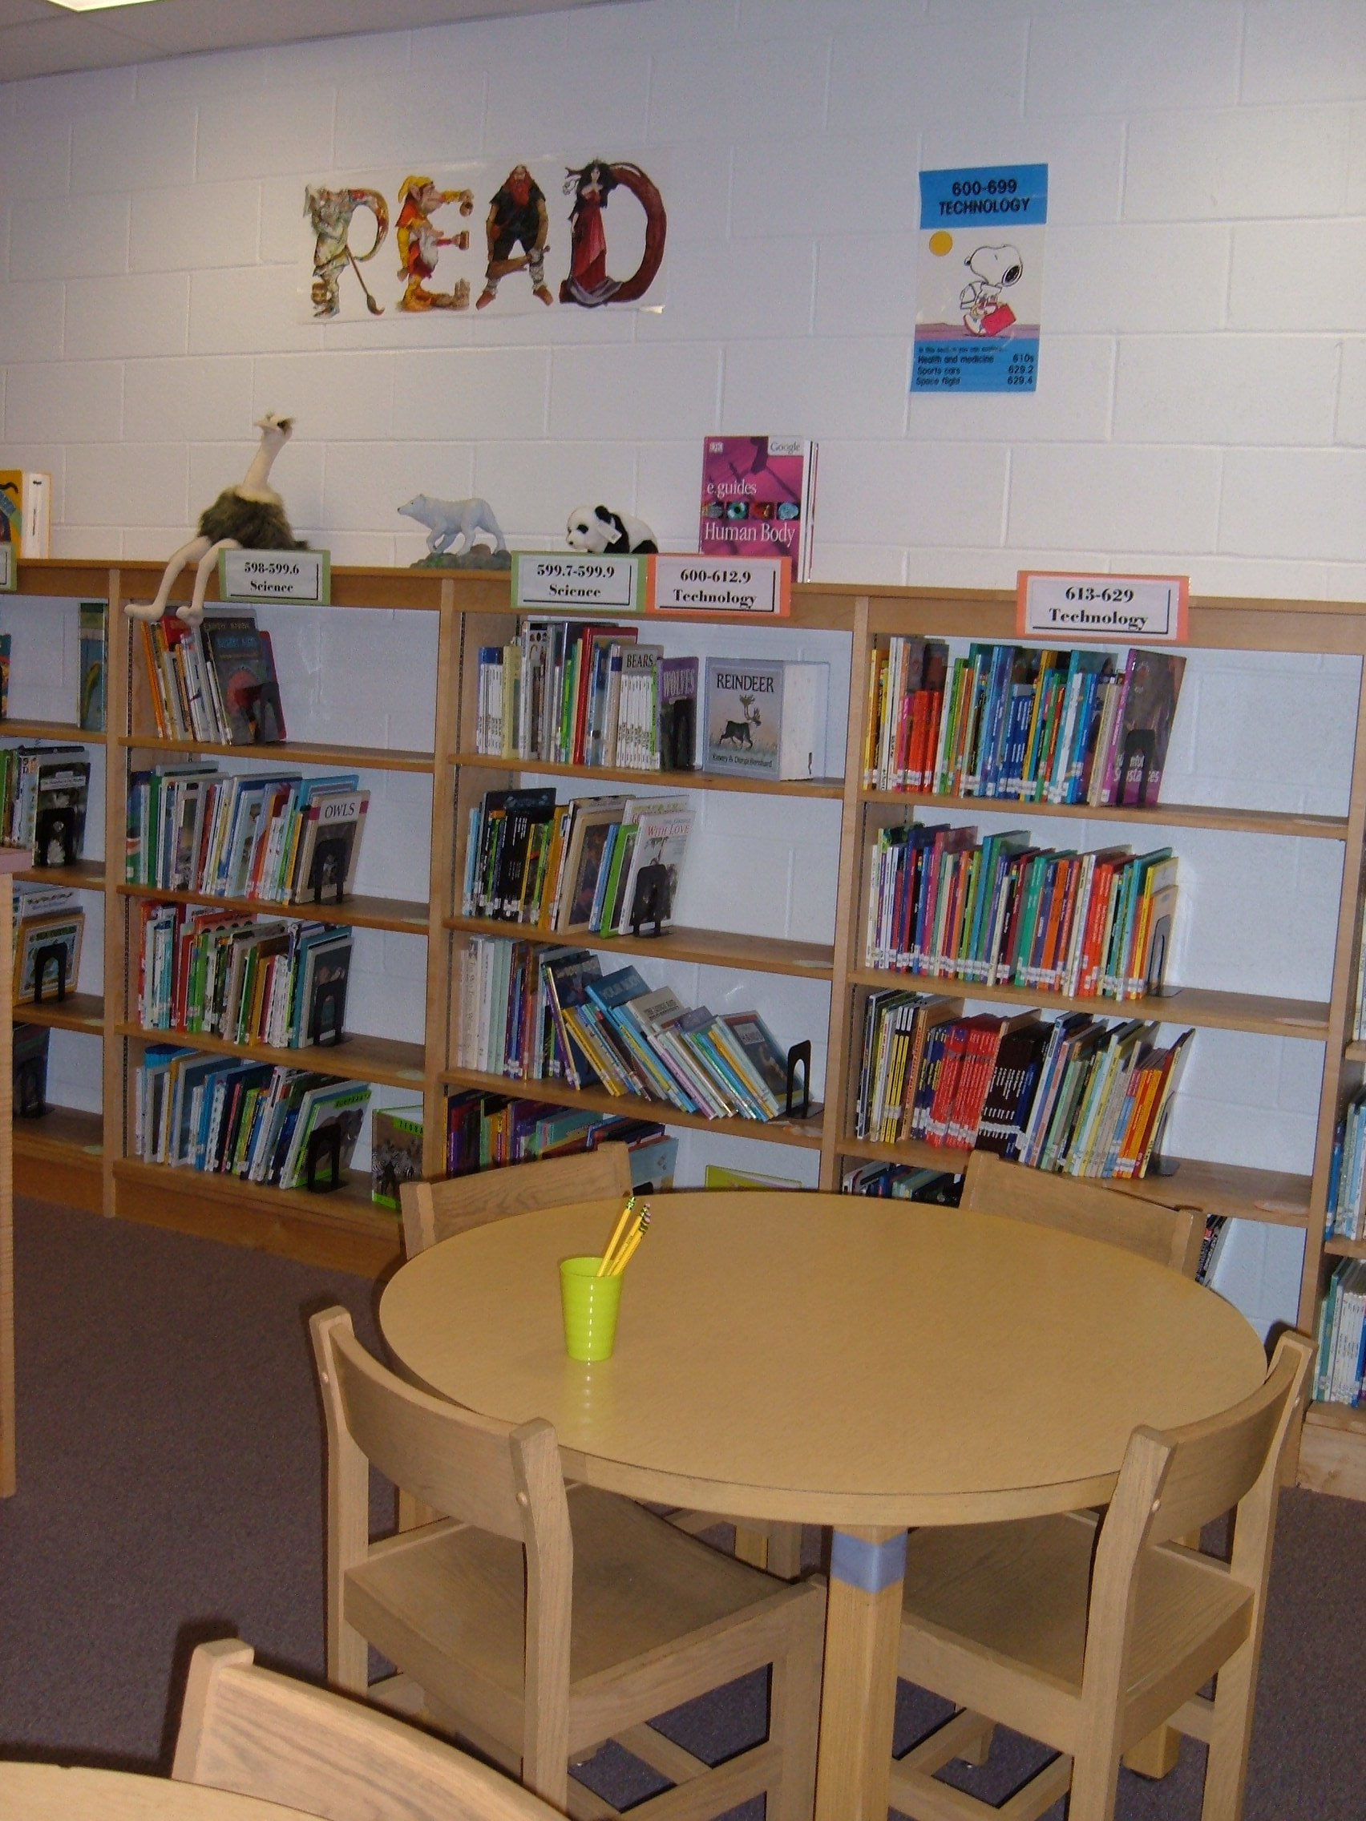
In addition to the Reference Section, keep in mind that we have a large collection of Non-Fiction books to use as resources as well!

We also subscribe to many journals, magazines, and newspapers which could sometimes be just as helpful when researching a topic. Below is a list of the magazine and journal titles available to students:

American Girl Faces
Appleseeds Kids Discoverer
BMX Plus Looney Tunes
Cat Fancy National Geographic for Kids
Cobblestone Nickelodeon
Cousteau Kids Odyssey
Cricket Ranger Rick
Crinkles Scooby Doo
Dig Spider
Dirt Bike Sports Illustrated for Kids
Discovery Girl US Kids
Disney Adventures Your Big Backyard
Dogs for Kids Zoobooks
~^~^~^~^~^~^~^~^~^~^~^~^~^~^~^~^~^~^~^~^~^~^~^~^~^~^~^~^~^~^~^~^

Our school Media Center also has a subscription to two terrific on-line resources:
World Book Online and SIRS Discover. From these sites, you can get to even more articles and journals! I have a list of your Username and Password to access these sites from school. You can even access them from home, using the information below. While here in school, you can get to these websites from any of our OPAC stations.

World Book Online: SIRS Discover:
http://www.worldbookonline.com http://discoverer.sirs.com
U: ccps P: media99 U: ccpes P: elem
Now that you can get your hands on a ton of helpful research materials, what can you use them for??

When you are given a research topic to investigate, there are several steps you will need to go through. Below is a description of each of those steps:

I. Planning For Research

Before you begin to randomly flip through the resources in our Reference section, you should have a purpose. In most cases, your teacher will assign a general topic to you. For example, you may be asked to investigate a well-known person from the American Revolutionary period, or a particular animal. Instead of just reading everything there is to know about that topic and writing down a long list of disorganized notes, think about what you need to know as the student, and what your audience wants/needs to know. It would be a good idea to create some kind of organizer to plan out the categories of information. You may create a web, a character trait sheet, a list, or some other kind of graphic organizer. One of the most helpful organizers for research is an outline.

II. Creating an Outline

Keeping your audience in mind, think about the major categories of information. This is where the encyclopedias can especially come in handy. Read through all of the information and decide which parts you want to focus in on. Think about your own questions about the subject, things that you are curious about. Think about significant facts that affect our history or our surrounding world. If you are researching a particular animal, your basic outline may look something like the one I have created on the next page.
Horses

  - History
  - Breeds
    - What different breeds are used for
    - Color and size
  - Uses
    - Transportation
    - Battle
    - Leisure / Fun
IV. Caring for

III. Finding Resources

In earlier sections of this handbook, you were introduced to a variety of resources. So, where do you begin your search? Start general, then move into more specific information. As I mentioned before, you may want to start with an elementary encyclopedia. This can jumpstart your ideas. From there you can go to specific non-fiction books, journal articles, and subject-related websites. Use our OPAC catalog system to find just the right resources for your particular topic. If you just want to browse first, think about the Dewey Decimal System.

000 – 099 Generalities
100 – 199 Philosophy, Psychology, Logic
200 – 299 Religion
300 – 399 Social Sciences (economics, sociology, civics, law, education,
careers)
400 – 499 Language
500 – 599 Pure Sciences (math, astronomy, physics, chemistry, biology,
geology, zoology, botany)
600 – 699 Technology and Applied Sciences (medicine, engineering, agriculture,
home economics, business, radio, television, aviation)
700 – 799 Arts (architecture, sculpture, painting, music, photography, recreation)
800 – 899 Literature (novels, poetry, plays, criticism)
900 – 999 Geography, History

[Remember, our Biography section – “the 92s” – are pulled out separately from the rest of the collection.]
IV. Evaluating Sources

Be aware that not everything you read will be completely correct or up to date! Because of this, it is wise to use more than one kind of source, or multiple sources of the same kind. Think about the author of the information. Is he/she an expert? Does he/she have experience in this topic? Does the author have a bias, or prejudice, in this matter? Was the resource published last year, or ten years ago? When you find the same information in more than one source, you can more safely assume that you can count on the information.

V. Note Taking / Note Cards

Once you have created your outline/plan, and found reliable sources of information, you can begin to record what you have found about this topic. One way to do this is to create note cards. When you record the information, be sure you also list which resource the information came from (just in case you need to check the information or get more information later). Some students choose to color or number their note cards, to keep them better organized.

Each card should have a heading so that you know which category it represents. It should also contain information about your resource (title, author, publisher, etc.) We’ll discuss this a little later in the handbook. The information you record should be of a length and detail that helps you remember the jist of it later when you are including the information into your presentation. You may choose to use phrases or bullets. Keep in mind that simply copying the author’s words and using them that way in your presentation is considered plagiarism (which is a fancy word for illegally copying someone else’s work). Not only is it more legal to restate or summarize the author’s words, it also proves to yourself and to your audience that you understand the information yourself. If the note card system just doesn’t work for you, consider using a note-taking grid or some other way of recording the information.
VI. Citing Your Sources

Think back to what I mentioned about evaluating sources, and about not taking the author’s exact words. To keep you focused on these ideas, you will need to cite (or give credit to) each of your sources of information. You will do this in the form of a Bibliography. This is a list of all of your resources by type, and then by author’s last name. Each type of resource has a very particular way of being cited.

Book: Each entry should include the author, title, publishing city, publishing company, and copyright date.

Example:

Rue, Leonard Lee. Wolves – A Portrait of the Animal World. New York: Todtri
Productions Limited, 1994.

Magazine: Each entry should include author, title or article, name of magazine, date, and page numbers.

Example:

Grag, Rudolph. “Build An Electronic Car to Foil Thieves.” Popular Science
Monthly, October 1988, p. 140.

[If you use an online source, check with your teacher or me to cite it correctly.]

VII. Presentation

Now, for the fun part! You’ve finished all the hard work! Now you get to show off your final product. There are many ways to publish your final research results. This may be up to your teacher, or she may allow you to be creative. You could use a traditional pencil and paper written report with multiple paragraphs. Or, you could include some technology by creating a slide show using a program, such as Microsoft Power Point. In these kinds of forms, be sure to include plenty of graphics that support your ideas, and capture the audience’s attention. You may also choose to act out your presentation in the form of a skit, interview, or short movie, etc. Keep your audience in mind. The possibilities are endless! Have fun!

Please let me know if I can help you along the way in this research process! ☺

