Burleigh Manor Middle School
Media Center
Policy Essentials
Handbook

Updated July 12, 2009
Prepared by Beth van Kan

Table of Contents
Introduction 4
Vision and Mission of Burleigh Manor Middle School 5
Mission and Vision of the BMMS Media Center 6
Media Center Policies 7
Hours of Operation: 7
Guide to Visiting the Media Center: 7
Circulation Policy: 8
Program 9
Collaboration and Planning 9
Community and Students 9
Staff 9
Yearly Goals and Planning 12
Media Center Personnel 14
Media Specialist 14
Media Paraeducator 14
Adult Volunteers and Student Aides 15
Substitutes 15
Collection Development 16
Selection Policy 16
Selection Criteria 16
Gift Materials 17
Ordering Procedures 18
Getting Orders ready…… 18
Ordering using the Integrated Financial and Administrative Solution (IFAS)… 18
Ordering Books and Other Print Materials 19
Vendors That Provide Our Accepted Processing 19
"Do Not Exceed" Orders 20
Other Orders 20
Additional Titles to Fill Orders 20
Series Titles 21
Standing Orders 21
Paperback Books 21
Periodicals 21
Newspapers 21
U. S. Government Publications 21
Ordering Audiovisual Materials and Instructional Software 22
Instructional Software 22
Direct Payment Request 22
Ordering Audiovisual Equipment and Computers 22
Budget 23
Library Media Supply Account (3292200) 26
Other Accounts 26
Furniture 26
Expense Table 27
Legal and Ethical 28
Acceptable Use 28
Censorship 28
Challenged Materials 28
Copyright 28
Intellectual Freedom Statement 29
Plagiarism Definition and Policy 29
Collection: Maintenance and Records 30
Additions and Withdrawals 30
Inventory 30
Weeding 30
Bibliography 31

Introduction

The Media Center at Burleigh Manor Middle School (BMMS) strives to create an environment where all of the school community (students, staff, administrators, and parents) are welcome and have access to as much information as possible taking into consideration the school curriculum and creative and informational needs of a thriving middle school community.

This handbook is designed to be a resource for the Burleigh Manor Middle School Media Center Staff and School Administration.

This handbook in an effective compilation of the essential information thoroughly detailed by the Howard County Media and Technical Services Department in the Handbook for Library Media Specialist and Administrators.

The HCPSS handbook is found in the HCPSS Collaborative Learning Community Intranet and requires official access; therefore, is not accessible by everyone.

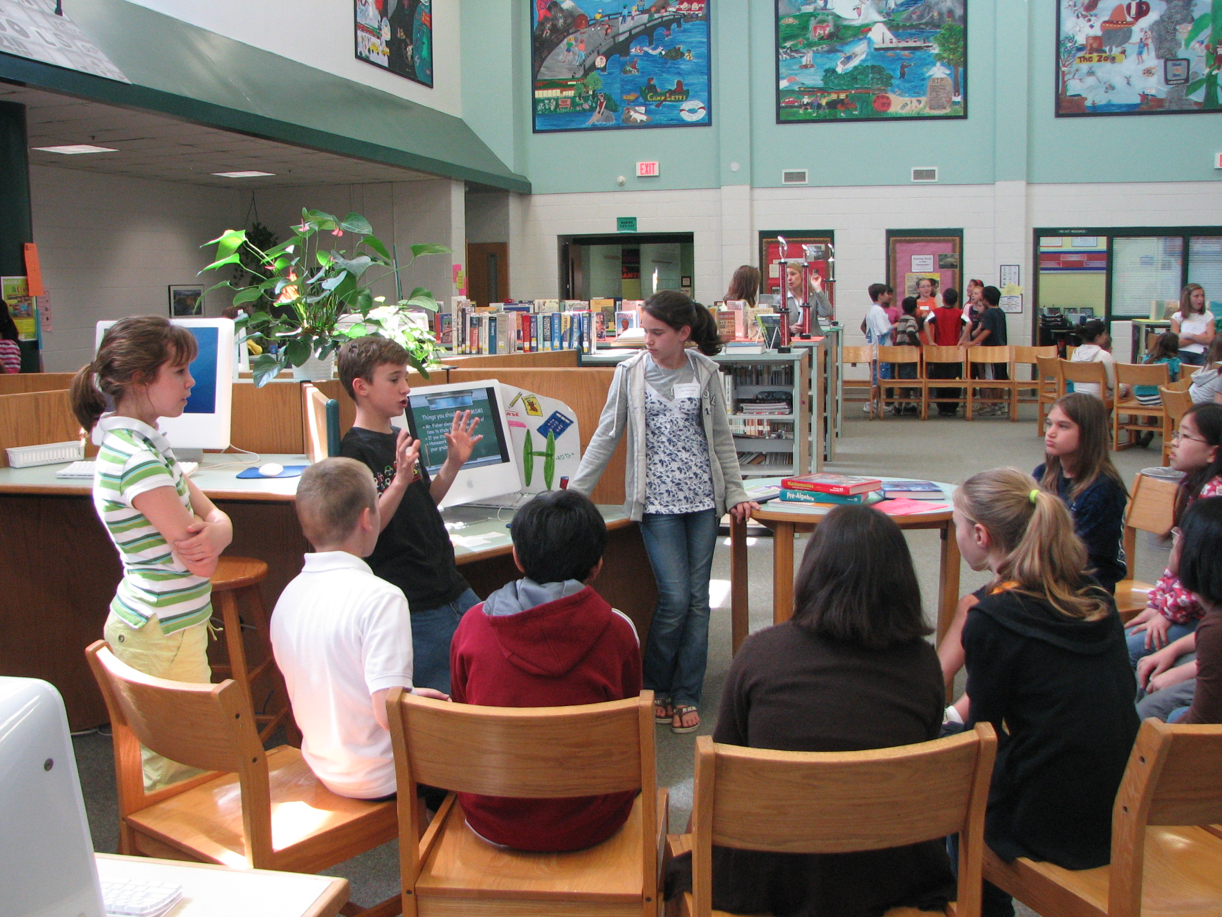
Back to Table of Contents

Vision and Mission of Burleigh Manor Middle School

The Media Center is an ardent supporter and contributor to the vision and mission of Burleigh Manor Middle School as prescribed by the administration:

Burleigh Manor Bobcats
ROARRR For Success
Readiness + Responsibility + Respect = Success

Burleigh Manor Middle School provides a quality instructional program that supports and respects the diverse needs of lifelong learners in a safe and nurturing academic community. Burleigh Manor is committed to academic excellence as we work to provide the knowledge, skills, and experiences necessary for all students to succeed in a globally dynamic 21st century. Burleigh Manor Middle School will embrace the cultural diversity of our students. Our school community will value the wisdom of change as we strive for ongoing improvement, we value our parents as partners and we value our supportive learning environment that provides exemplary teaching and learning.

- Claire Hafets, Principal


Back to Table of Contents

Mission and Vision of the BMMS Media Center

The Mission Statement of Your Media Center: A Promise to You…

To provide access to inquiry, resources, and answers by means of the printed word and use of technology while promoting the pleasure of reading books, to all who enter here; and here you are very welcome.

The Vision of Your Media Center Statement: A Promise to You…
The Media Center is committed to the individual. We are dedicated to protecting the freedom of intellectual curiosity and serving all who enter with respect and kindness as they seek to gain knowledge through exceptional and varied resources.

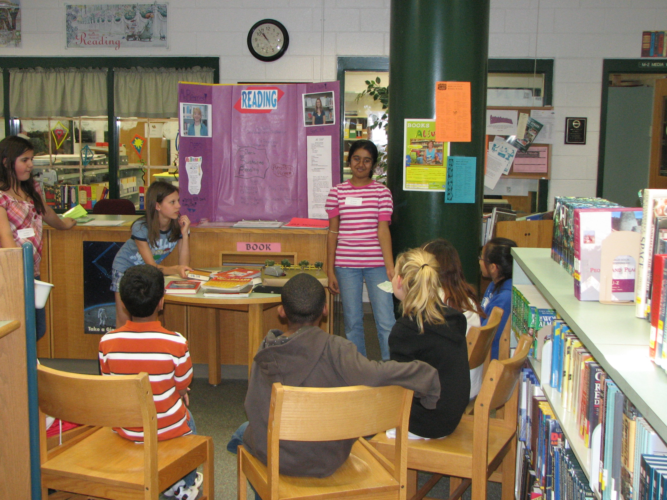

Back to Table of Contents

Media Center Policies

Hours of Operation:
7:55am - 3:00pm on all school days when school is a full day
- The Media Center is always open to the school community during the school day.

- Staff may reserve classroom space in the Media Center or Computer Labs by putting their name on the schedule that is located in the Media Center Workroom.

- The schedule to reserve space is available quarterly, one week before the beginning of the next of the quarter.

Guide to Visiting the Media Center:
- Students may visit the Media Center during their lunchtime by obtaining a “lunch pass”, from the circulation desk, before the first lunch period of the day

- Students may visit the Media Center any time of the school day but must have a pass from their teacher

- Students should record their whereabouts on the “Sign Out Sheet For Media Center”, located on the circulation desk, if they need to leave the Media Center for any reason

- Remember to be respectful of teachers and students having classes in the Media Center

- Quiet talking is always welcome in the Media Center

- Ask the media specialist, the media assistant, your teacher, or a friend, about anything you need help locating or learning how to use in the Media Center

- Reading is strongly encouraged in the Media Center and at ALL times

- Following the HCPSS “Internet Policy” and “Technology Use Agreement”, signed at the beginning of the year, is mandatory when using a computer

- All school rules are in effect within the Media Center

Back to Table of Contents

Circulation Policy:
The circulation policy gives prime consideration to the maximum use and flow of materials throughout the school and for home use. Lending regulations strive to be fair, with loans renewable, unless there is justification for limitations.

Loan Periods and Renewals
- 4 items (books, audio/visual, etc) per students for a loan period of 3 weeks

- Students are encouraged to borrow all types of materials.

- Practicality will determine the extent to which students may borrow equipment for home use.

- Teachers may request materials be pulled for use in their classrooms for extended periods of time.

Overdue Materials
Students are encouraged to be responsible users of materials; however, the opportunity to check out materials will not be withheld due to overdue materials

Lost or Damaged Materials
The user responsible for the damage or loss should pay for materials damaged beyond repair or lost.

Back to Table of Contents

Program

The Burleigh Manor Media Center aligns its usage and services with the HCPSS goals and objectives. Specifically:
- Curriculum development
- Teaching
- Providing access
- Encouraging the use of resources; books, technology, multimedia, and other creative sources
- Supporting the learning of all students
- Maintaining a collection that is diverse in format and content

Collaboration and Planning

Community and Students
The Burleigh Manor Virtual Library provides access to:
- All of the databases the school subscribes to
    - Users must have their passwords and logins to use them
    - This information is on a label in the front of each student’s BMMS Daily Planner
- The Burleigh Manor Public Access Catalog
- Online Resources for research
- All HCPSS Media Centers which we have an Inter Library Loan system for
- The Howard County Public Library
- Contests
- Book Awards
- Teacher Resources
- The HCPSS Writing Style Handbook

Additionally, the Media Center sponsors community events like: Book Fair, Open Mic Poetry, and Black-Eyed Susan voting, and actively supports author visits, G/T Enrichment Night, PTA events, and more.

Staff
The Media Staff seeks out opportunities to collaborate and plan lessons with all staff members. The goal is to provide students with the opportunity to attain and practice information literacy skills. The following documents are aids in this process:
- The “Collaboration Planning & Teaching Log” can help a collaborating media specialist and teacher establish a lesson plan
- The “Unit/Lesson” guide is a tool for the media specialist to use to plan their part of the lesson:

Back to Table of Contents
Burleigh Manor Media Center
Collaboration Planning & Teaching Log
Teacher(s): ______________________________________________________
Grade Level: __________________________ Planning Date: _____________ Project Date: _________
Library Information Literacy Standards: The student who is information literate  - Accesses information efficiently & effectively  - Evaluates information critically & competently  - Uses information accurately & creatively  The student who is an independent learner is  - Information literate & pursues information related to personal interests  - Information literate & appreciates literature & other creative expressions of information  - Information literate and strives for excellence in information seeking and knowledge generation  The student who contributes positively to the learning community and to society is  - Information literate & recognizes the importance of information to a democratic society  - Information literate & practices ethical behavior in regard to information & information technology  - Information literate & participates effectively in groups to pursue & generate information | Objectives/Goals
Project Description (including estimated timeline & use the back if more room is needed to write):

Teacher will: |  |  | Library Media Specialist will:
Resources: | ___ Hyperstudio | ___ Scanner | Evaluation:
___ Internet | ___ WNOR | ___ | Evaluation:
___ PowerPoint | ___ Kid Pix | ___ | Evaluation:
___ Word | ___ Inspiration | ___ | Evaluation:
___ Excel | ___ Digital Cam. | ___ | Evaluation:
Attach any other handouts, notes, or materials created for the project.

Back to Table of Contents
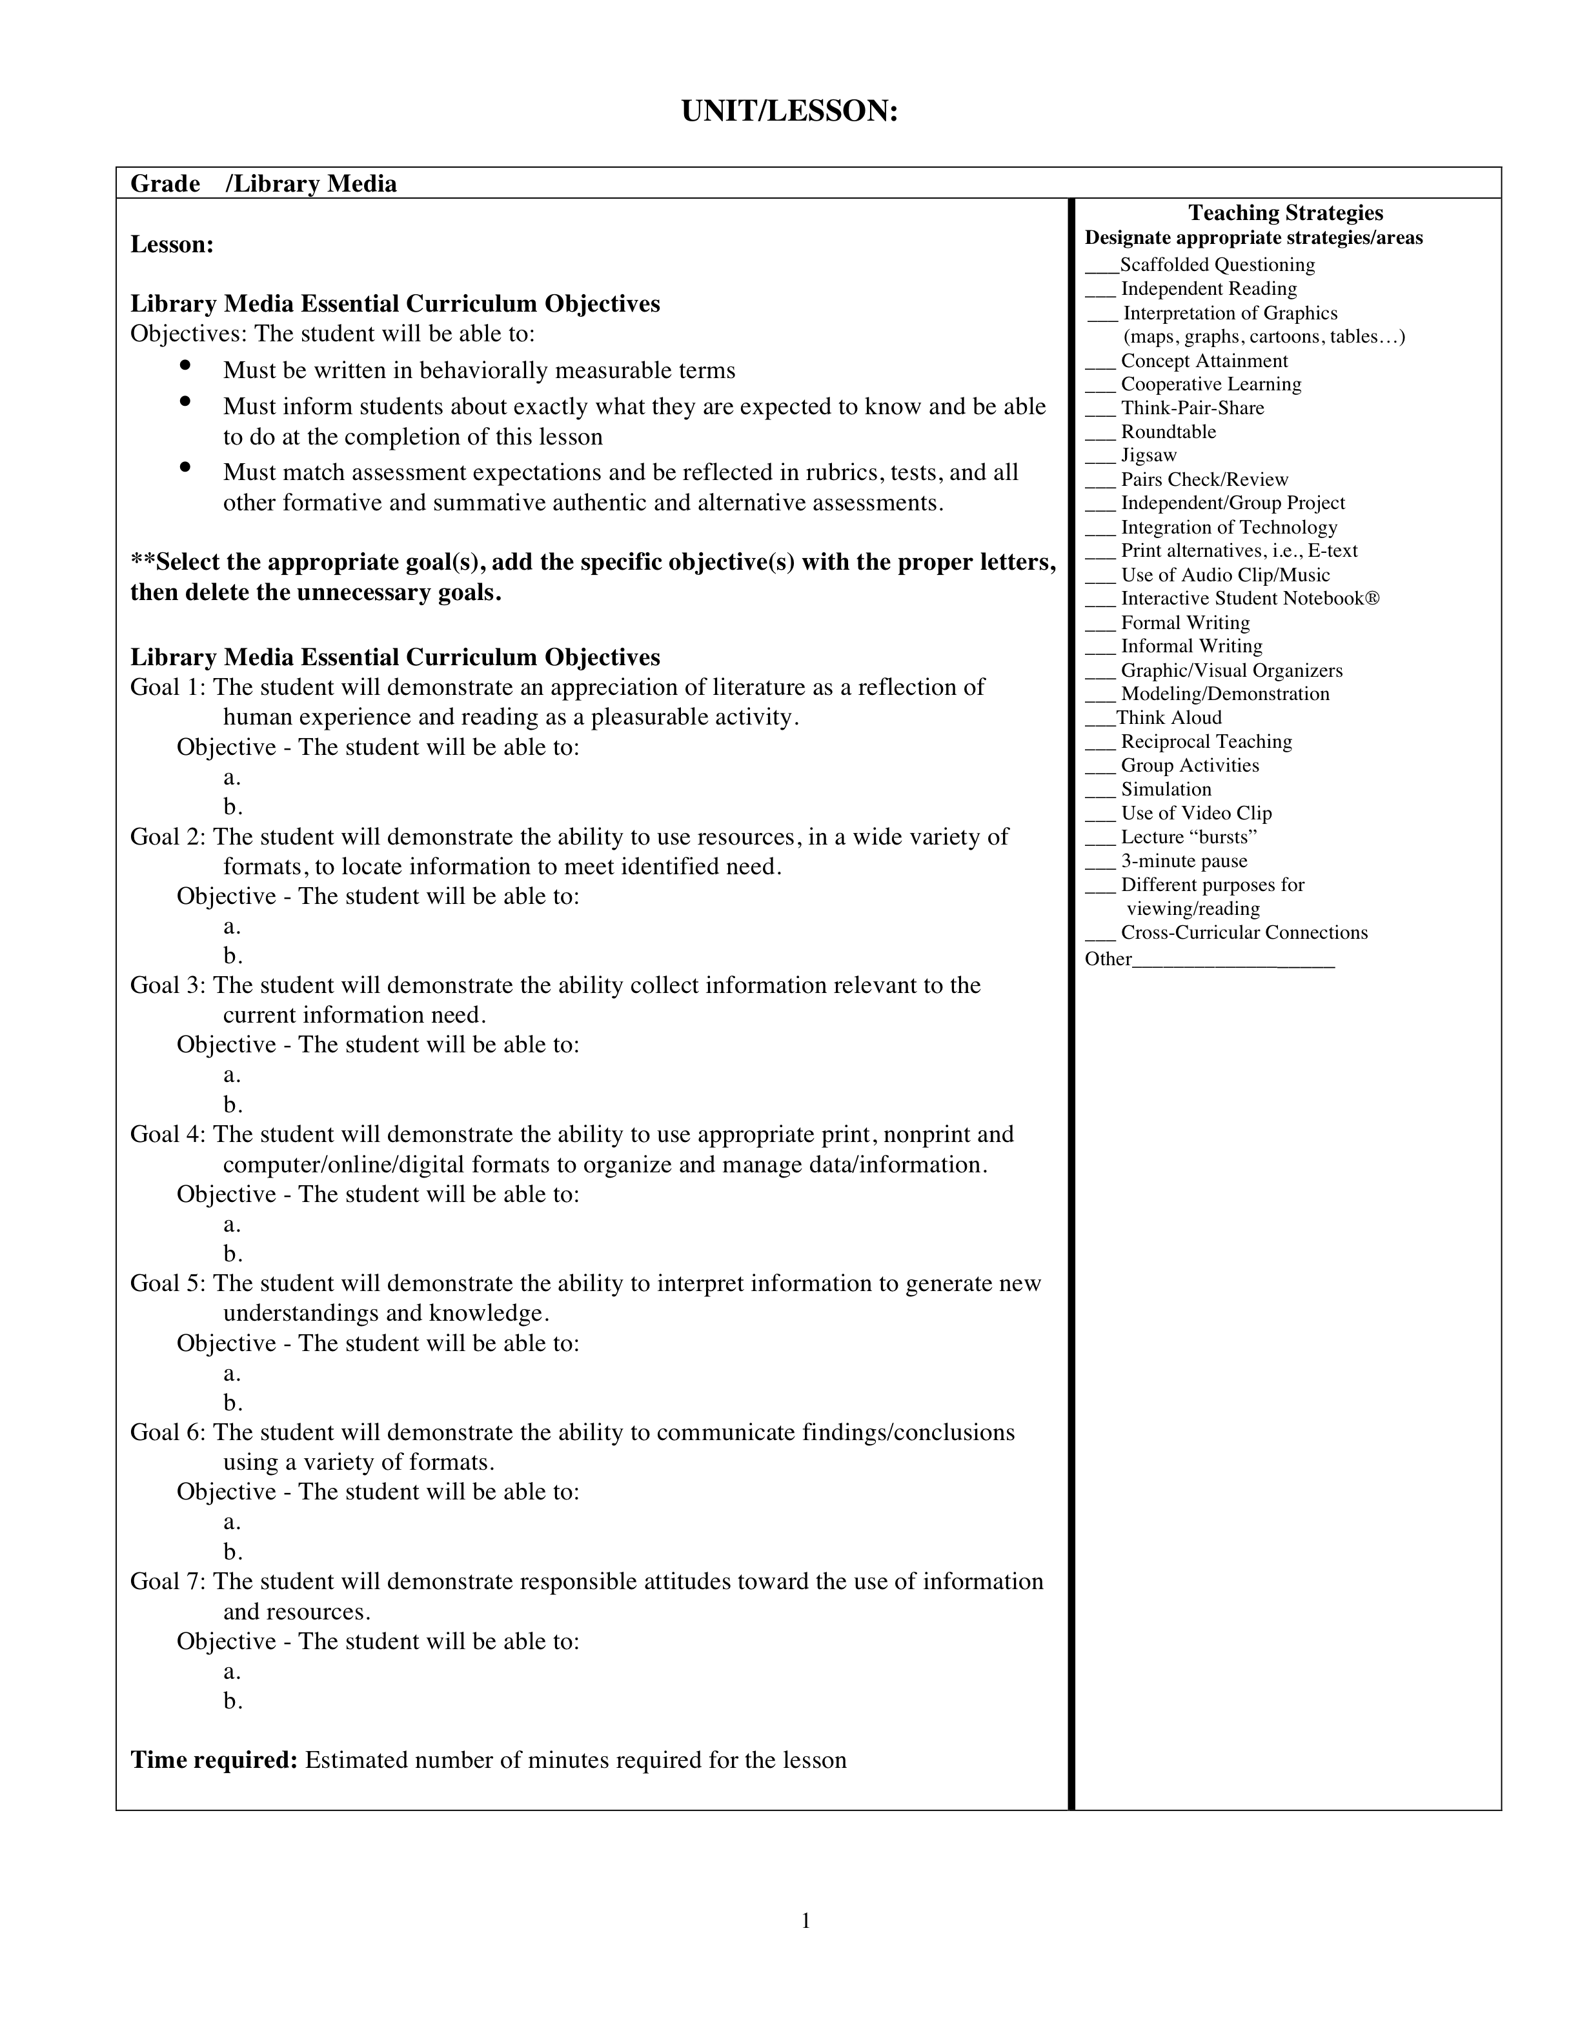

Back to Table of Contents

Yearly Goals and Planning
Each year the media specialist will select one of the goals of HCPSS and coordinate their own personal goal with it to achieve the objectives that judge its success.

The HCPSS goals support meeting yearly county and state testing standards and expect the support of the media specialist to help meet these goals.

Specifically, it is this year’s goal of the media specialist at Burleigh Manor to:
- Collaborate in planning and teaching two times this school year with each department
- Constantly review resources (will be accomplished through effective continual weeding and selection according to policies conveyed in this handbook)

Focus will be on meeting the following HCPSS goal for the media specialist, with the added media specialist’s goal of additional collaboration:

HCPSS Goal:
The library media program is essential to learning and teaching and must be fully integrated into the curriculum to promote students' achievement of learning goals.

The following objectives as proof of progress:
- Use Media Essential Curriculum as a basis for curricular and instructional planning.
- Collaborate with teachers and staff to develop curricular content that integrates library media and technology skills, as outlined in the goals and objectives included in the Media Essential Curriculum, as well as Library Media Skills Scope and Sequence.

The result of the media specialist’s goal will be:
- Continuing yearly collaboration with each department that result in HCPSS meeting the specific goal as stated above
- Relevant materials and technology collection

Establishing and enacting these goals successfully can be recorded by completion of the prior two templates (p. 10 & 11) for collaboration and lesson planning, as well as, by using the following document as a source of historic record keeping:

Back to Table of Contents

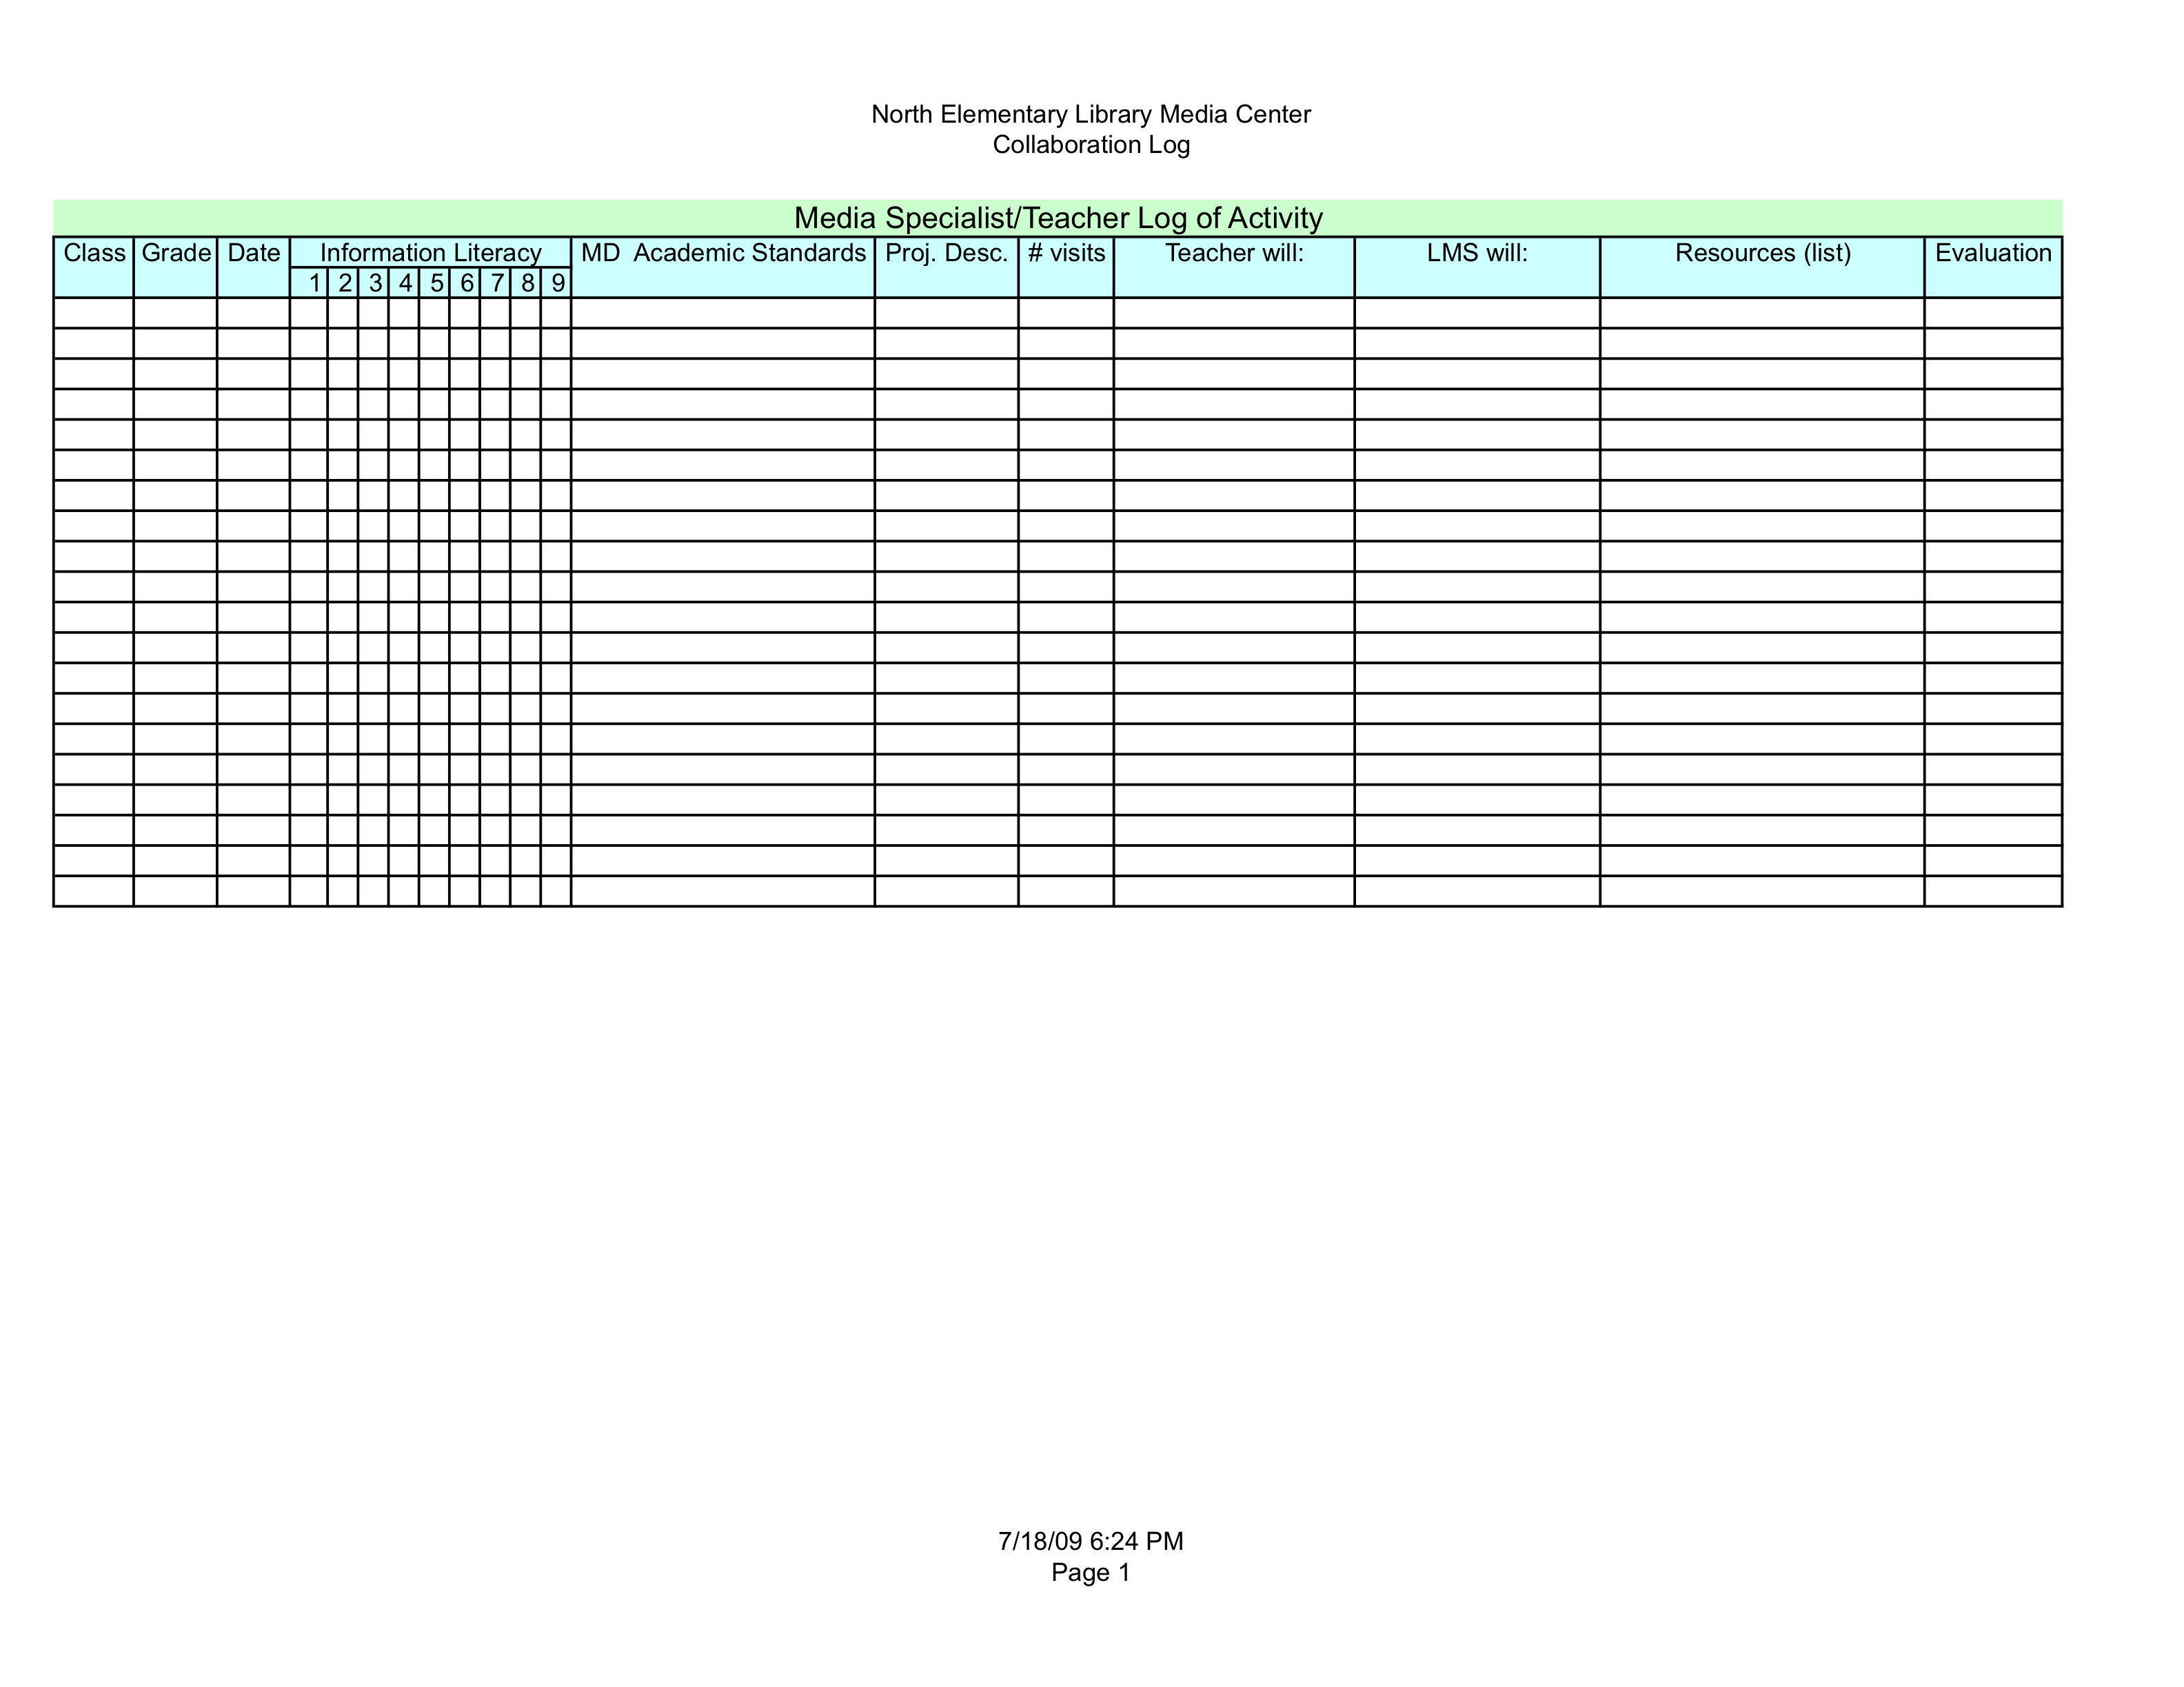
Burleigh Manor Middle School Media Center Collaboration Log

Back to Table of Contents

Media Center Personnel

Media Specialist
The Media Specialist manages the Media Center materials, facilities, (including use of the computer labs), equipment, and staff. The Media Specialist serves in the following roles and assumes these additional responsibilities:

- Teacher - works with all of the school community to convey information literacy skills using the most current resources

- Instructional Partner - collaborates with other teachers, working to integrate information literacy skills into the existing curriculum helping students learn both the subject matter and the information skills

- Information Specialist – helps the school community learn to find and evaluate information in all formats as well as model the use of information effectively to others; attends local, state, and national professional conferences

- Program Administrator - develops policies and procedures for the library media center while managing the everyday operations of the library media center and the coordination of the technology program in the school

Media Paraeducator
The Library Media Paraeducator assume the following responsibilities:

- Relieve the library media specialist of many clerical tasks

- Assist with technology and instruction throughout the school

- Supervise the circulation system including data keeping and reports

- Perform and supervise housekeeping to keep Media Center and computer labs neat and clean

- Assists individuals and groups of students in such areas as book selection, reference, computer use, and media production

- Assist students and staff with the use of computers and software

- Perform any other duties assigned by the library media specialist

Back to Table of Contents

Adult Volunteers and Student Aides
There should orientations to the jobs that parents and student aides perform. Volunteers and Aides may:

- Assist with the circulation of materials

- Shelve books and other materials

- Check in periodicals

- Read shelves

- Assist in taking inventory

- Assist in preparing displays

Substitutes
The media specialist position at Burleigh Manor does not typically provide a substitute when the media specialist is out; however, if there were a time when a substitute was provided they could perform the tasks of the volunteers/aides. The media paraeducator would step in to cover any scheduled instructional activities.

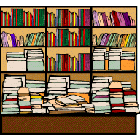

Back to Table of Contents

Collection Development

Development of the Burleigh Manor Media Center’s collection is the responsibility of the media specialist. The media specialist may engage the school community to assist in evaluating a variety of materials and selecting materials based upon the curriculum and the objectives of the school, and the media specialist’s selection criteria.

Selection is in conjunction with the Maryland State Department of Education publication, Standards for School Library Media Programs in Maryland in the appendix), the American Library Association standards, and HCPSS Policy.

Selection Policy
The School Library Media Center has the most important role in the education environment pertaining to the realization of information literate citizens. One of the School Library Media Center's purposes is to provide materials, equipment and services for the students and faculty it serves. Selection of these various materials is an ongoing and important responsibility of the Media Specialist.

Selection Criteria
Each item, whether print or non-print, is carefully evaluated within the framework of sound selection principles, using reliable reviewing sources and personal inspection of the materials whenever possible. The following standard selection tools are utilized:

- Book List
- Voices of Youth Advocates
- Publishers Weekly
- School Library Journal
- Written recommendations from two or more staff members or other educational professionals

These selection tools were selected from a reviewed list of resources provided by HCPSS Media and Technical Services Office along with the media specialist’s familiarity with their usage and reputation.

Standards:

1. Media Center materials should support the school curriculum

2. Materials should be relevant to today's world and represent artistic, historic, and literary qualities

Back to Table of Contents

3. Nonfiction materials should be functional, appropriate, accurate, and objective information

4. Fiction books should have varied qualities of plot, style, characterization, and theme

5. Media Center materials strive to be related in content and vocabulary to a diverse middle school student body and geared to satisfy informational, recreational, creative. and cultural needs

6. Materials should promote and enhance the development of responsible citizens of the world

7. Materials should reflect the problems, aspirations, attitudes, and ideas of society

8. Non-print materials should be of good technical quality

9. Materials are purchased from recommendations in reviews and standard lists

10. The School Library Media Center will house and provide access to materials that represent a variety of viewpoints on controversial subjects for information and research purposes

Gift Materials
Gift books or other materials, which are offered to library media centers, must meet the selection standards the above selection standards and HCPSS policy guide lines.

Back to Table of Contents

Ordering Procedures

Getting Orders ready…
- Does order meet selection policy requirements?
- Does order include at least three of the following: title, author, ISBN, or publisher.
- Is order organized by priority?
- For all orders, make 3 copies:
  - Submit two copies of the order to Media Technical Services
  - One copy of the order list should be prepared and used as a receiving copy by the school. (This copy may have additional information such as subject area, the name of the individual who requested the item, awards, reading level, etc)
- Copies of order lists should be maintained at the school for three years (for potential audit purposes).

Ordering using the Integrated Financial and Administrative Solution (IFAS)…
- IFAS is the program used to enter purchase requisitions from the library media accounts.
- It is important to note that once your funds have been requisitioned through an order the funds become encumbered and are no longer available for use until the purchase order is satisfied.
- The IFAS account number for Media Services has two parts. The Key number is 10XX041501 in which the 3rd and 4th digits are your school's IFAS code numbers.

The Object codes for library media are:
- Library/Media (books, audiovisual materials) 3220100
- Supplies (posters, key disks, pencils, etc.) 3292200
- Computer software and supplies 3292900

The Product Code for print and non-print materials is 71500000. For all other items, look up the product code in the IFAS system.

(A quick reference for vendor numbers used frequently by library media specialists can be found in the Vendor Numbers Frequently Used folder in the Media-Services CLC Conference)

Back to Table of Contents

Ordering Books and Other Print Materials
For book orders, a minimum of eighty percent must be ordered from the following companies:

- Baker & Taylor;
- Perma-Bound;
- Scholastic Library Publishing
- Grolier

Note: Some publications are not available from these vendors and should be ordered from the publishers or specialized vendors.

Vendors That Provide Our Accepted Processing
Placing orders for these companies follows a slightly different process. Because the books are pre-processed, they are shipped directly to the school:

- Baker & Taylor, Inc (vendor #V01951-P2)

- Perma-Bound (Vendor #V01229) - Catalog prices reflect the 22% discount given to HCPSS.

- Scholastic Library Publishing (vendor #V02269-P3) and Grolier Publishing (vendor #V02269-P3)

- Scholastic handles Children's Press, Franklin Watts, Scholastic trade titles, and Grolier.
      - The prices listed in bold print in the vendor catalogs reflect the 30% discount on Children's Press and Franklin Watts titles and the 40% discount on Scholastic trade titles.

IMPORTANT: When completing orders for these companies, follow these directions:

- Orders will be shipped to BMMS, use the school's IFAS # with the following information:

      - Attn: Library Media Center
      - In the IFAS Print After field, enter:
      - "Please send vendor copy of PO to Judy Litz, MTS, for mailing."
      - "Free shipping/handling"
      - "Full processing for all titles FREE of charge"

Back to Table of Contents

- Send two copies of the list of titles with the RQ# and the school name to Judy Litz at Media Technical Services: keep a copy of the list at the school for checking in the order and for audit purposes (must be retained for three years).

- When the books arrive, do not open the boxes until Judith Jurgenson gives notification that the titles have been merged with the database.

- After hearing from Judith, open the boxes and check the items against the order list and packing slip.

- If there are any discrepancies in the order, contact Judy Litz at Media Technical Services via CLC.

"Do Not Exceed" Orders
"Do Not Exceed" orders are ones for which the vendor is to provide as many items from a list as possible with the indicated amount of money. The total should include shipping/handling.

Other Orders
When ordering from vendors other than those listed above, follow these directions:

- Orders from other vendors are to be shipped to Media Technical Services (IFAS # L13J).

- Leave the End Use field blank [this will automatically generate shipping to Media Technical Services].

- Enter any shipping/handling costs as a line item.

- Enter any discounts as a line item.

- In the IFAS Print After field, enter any text that is to appear on the Purchase Order (e.g., if a vendor/sales rep indicated shipping would be free, enter that name; note if coupons are attached; etc.)

Additional Titles to Fill Orders
Be sure to always have a list of additional title on hand. In the event that the order cannot be filled, these titles should be ready to be supplied to the vendor to fill the order.

Back to Table of Contents

Series Titles
Titles in a series, even if previous titles are already approved, must have a positive review or they must be read and have a “Selection Criteria for Media Center Materials” form completed (indicating that the title is appropriate/approved).

Standing Orders
Standing orders are not permitted.

Paperback Books
Paperback books are not cost effective materials and ordering them is discouraged.

Periodicals
- Periodicals to be used by students must meet the same criteria as books (see above).
- A combined order is compiled from all school requests, and all subscriptions are placed with one jobber for one calendar year.
- Professional periodicals, used only by staff, are automatically approved.
- Periodicals to be used with students that do not appear on the approved list may be purchased by completing the Selection Criteria for Media Center Materials form.
- The completed form should be forwarded to Media Technical Services with the periodical order.

Note: Each school is informed of the cost of its periodicals in the fall of the following school year. The amount is deducted from the library media center materials account at that time.

Newspapers
The Media Center subscribes to the following newspapers:

Local newspapers – Columbia Flier, Howard County Times
Large city newspapers –The Baltimore Sun, The Washington Post

Payment for newspapers is handled through the library media supply account.

U. S. Government Publications
Government documents are available for purchase from the U. S. Government Printing Office (http://bookstore.gpo.gov). Materials may be ordered through IFAS. Payment must accompany the order. In IFAS, enter "Check enclosed" in the Print After field.

Back to Table of Contents

Ordering Audiovisual Materials and Instructional Software
Audiovisual Materials

- Audiovisual materials (AV) must meet the same selection criteria as books.

- Audiovisual materials may be purchased from the library media center materials account (3220100). Follow the directions found in Other Orders above to complete IFAS orders for AV materials.

- When ordering a series of AV materials, please send Media Technical Services (MTS) a copy of the catalog page or a list of titles in the series so that MTS personnel can determine that all items in a set/series have been delivered.

- “R” and “NC-17” rated videos, and non-rated feature videos produced after 1990 may not be shown to classes in Howard County Public Schools.

Instructional Software
All software to be used with students must meet COMAR regulations. Before ordering any software, check the HCPSS listing of approved software (http://www2.hcpss.org/purchasing) for approval information.

Call the SAP Test Lab Specialist with questions at x7178 or email Holly Windsor at (hwindsor@hcpss.org).

Direct Payment Request
The use of Direct Payment (DPs) shall be limited to emergency orders and for those vendors not accepting VISA (HCPSS P-Card) credit payments.

Ordering Audiovisual Equipment and Computers
Audiovisual equipment and computers may be ordered from the Replacement Equipment Account or other school-based accounts.

- Consult with the principal about using these accounts.

- Select new equipment from the current AV Equipment Catalog that is available online at http://www2.hcpss.org/purchasing.

NOTE: Any requisition to purchase audiovisual equipment other than that listed in the current AV Equipment Catalog is to be accompanied by a written justification to support the purchase of such equipment. Letters of justification must come from the school principal. Send letters of justification (it may be emailed) to the Technology Service Center.

Back to Table of Contents

Arrival of equipment:
- Equipment should arrive within 90 days
- Determine that the correct materials have been shipped
- Verify that the equipment works
- Complete the receive items process in IFAS so that Accounts Payable can pay the vendor.

The Media Processing Procedures for HCPSS is very specific, and, therefore, follows:

Back to Table of Contents

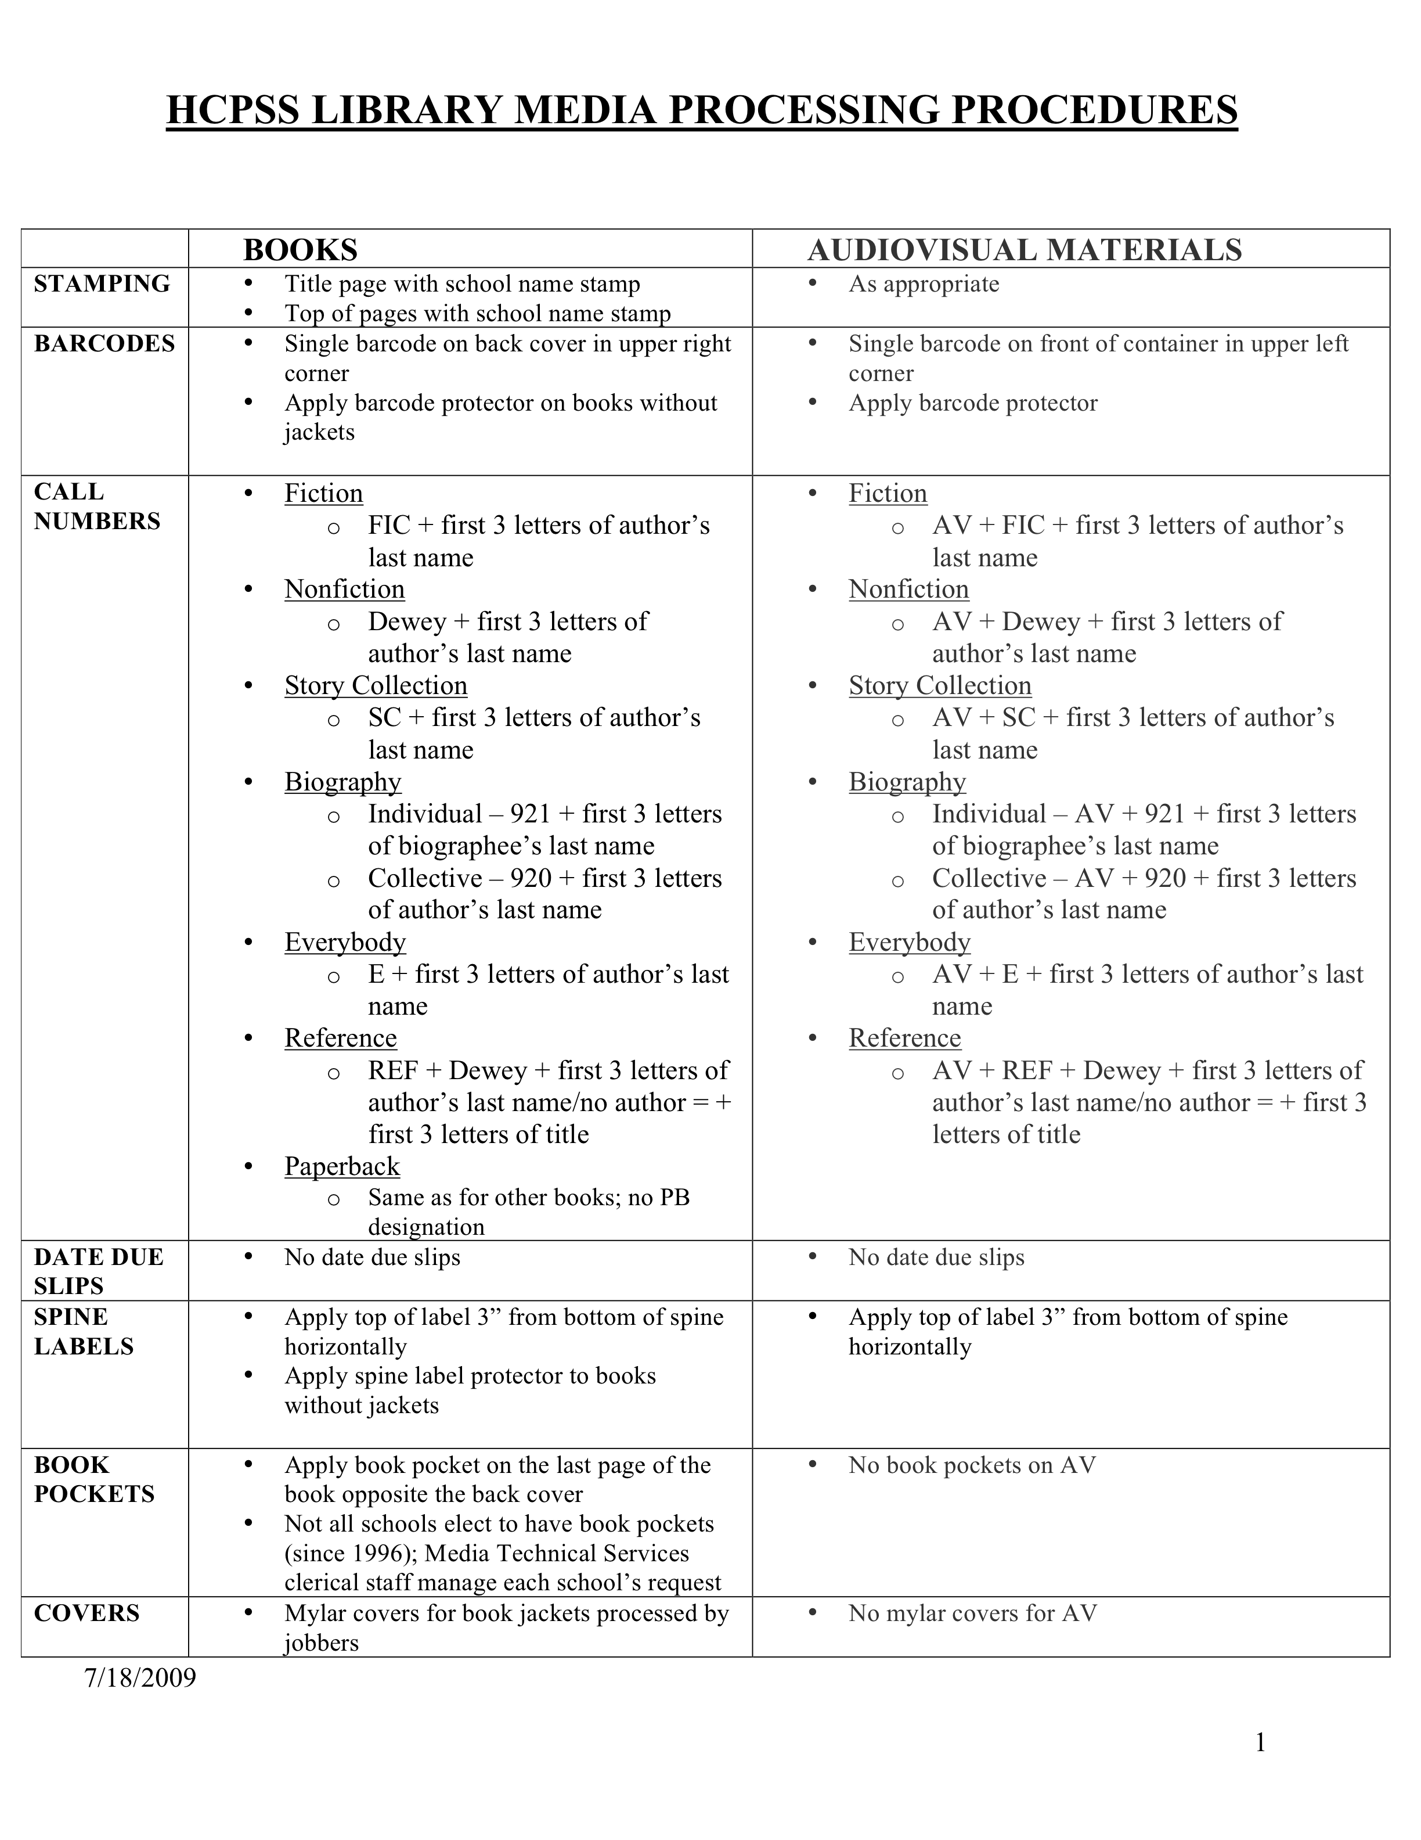Back to Table of Contents

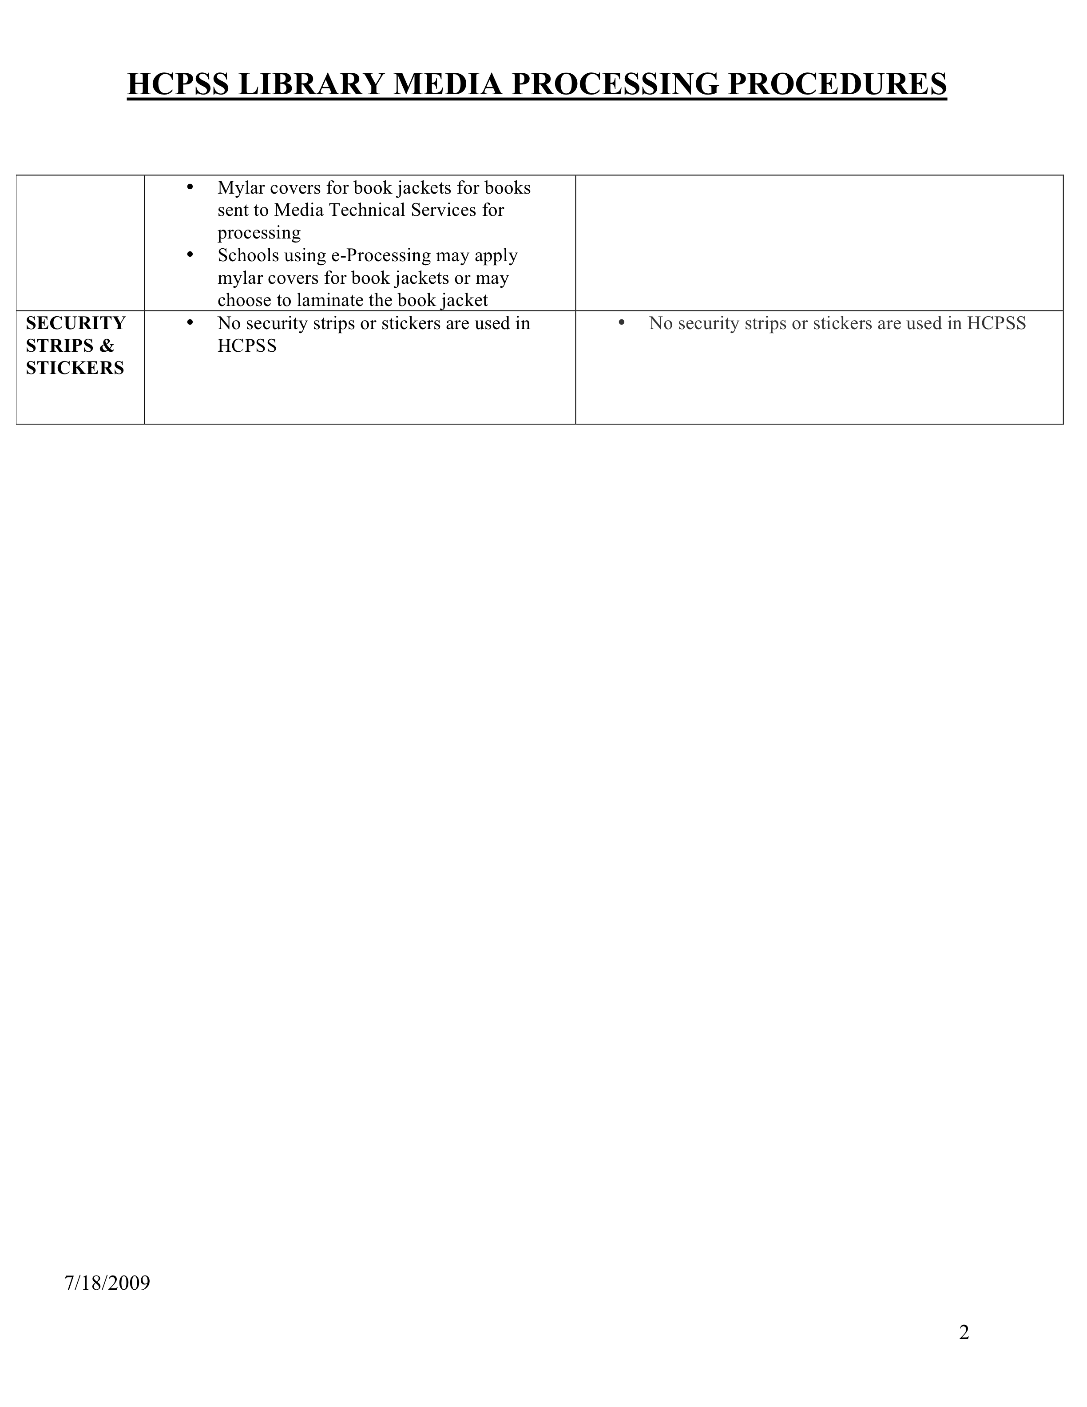 Back to Table of Contents

Budget

Funds are allocated to the Media Center on a “per pupil” basis. The monies become available at the beginning of July; spend the money in this budget as soon as possible. Funds should be spent on high quality books and other materials used by students during the school year.

Library Media Supply Account (3292200)
There is an annual allocation for library media and audiovisual supplies (library media lesson supplies, posters, lamps not provided by the Office of Technology, computer printer supplies, etc.). Purchases from this account are to be made for library media center materials by the library media specialist, with the approval of the school principal. Orders may be placed using IFAS or with a Direct Payment Request form.

Other Accounts
Funds from “other” sources like book fairs and PTA donations are kept in a school based checking account. These funds are to be spent on purchases for the Media Center as deemed fit by the media specialist.

Furniture
The library media specialist should consult with the building principal who manages the funds for furniture, if new furniture is needed.

Expense Table
I have designed the table below as a way to estimate how to think about and use the Media Center funds from all income sources.

Back to Table of Contents

Usage Report  Type of Material | Percent of  Materials Checked-out  From August 20 – June 20 of Current School Year | Percent of Budget to Allocate for this Material Type
Fiction

Non-Fiction

Everybody

Graphic Novels

Story Collection

Professional Materials
Technology

Periodicals

- Run report to extract required information June 1
- Estimate the amount of funds to replace essential materials that had to be weeded
- Cull together an order that is always ready to go and constantly updated using the information and estimates from this chart

Back to Table of Contents

Legal and Ethical

Acceptable Use
Students and parents at Burleigh Manor Middle School must sign HCPSS policy that dictates the acceptable use standards of the Internet and the school technology. These policies include:
- Use of a confidential login and password to access the internet
- Only using technology and the internet in the presence of BMMS Staff
- Only using school county approved databases and teacher approved websites while in school
- Students are not allowed to access emails, chats, or blogs
Neglecting to follow these standards results in a loss of use privileges that could extend through the school year, as stated in the policies the student and parents sign.

Censorship
Every effort is made to provide students access to materials that: represent varied and multi-cultural viewpoints and histories, providing the opportunity for learning and growth.
- Meet the needs of the curriculum and the interests of its students, faculty, and staff
- Stimulate and support intellectual and social growth, literary appreciation, aesthetic values, and ethical standards
- Provide a balanced collection reflecting diversity in points of view and in treatment of controversial issues
- Meet criteria such as factual accuracy, timeliness, variety of format and appropriateness to level of user
- Take advantage of emerging technologies

Challenged Materials
In the event that any media center material is challenged by any member of the community it is the policy of HCPSS to:
- Refer the challenge to directly to the principal
- The principal is responsible for following re-evaluation procedures as per policy #8040
- Materials are removed from circulation until a decision is made

Copyright
The media specialist must strictly follow all copyright laws. School staff members are made aware of this fact and should not ask library media specialists to violate the law in any way. Periodic circulars concerning copyright law interpretation are distributed from the Central Office.
Copyright at School - MULTIMEDIA AND THE INTERNET
Copyright at School - PRINT AND VIDEO
Copyright at School - COMPUTER SOFTWARE

Intellectual Freedom Statement
The Media Center at BMMS is committed to providing students with materials and services “that create and sustain an atmosphere of free inquiry”, in accordance with the ALA’s interpretation of the Library Bill of Rights. The Media Center attempts to provide the most up-to-date support of the curriculum and needs of its school community through materials and technology for the sixth through eight grade students it serves and allow everyone access to these items. All policies of the Media Center support free and open access to this information.

Plagiarism Definition and Policy
Plagiarism is when a person uses the ideas or words of another person and makes it seem as if they are their own words or ideas by not giving credit to the source by documenting its use.

The act of plagiarizing work cannot be tolerated. When a student is suspected of plagiarizing work a conference will be held with the student, parent, teacher, and principal to determine the intentions and consequences of the action.

The BMMS Media Center provides the following links to information about plagiarism:
Plagiarism.org
Plagiarism Tutorial: You Quote It, You Note It!

Back to Table of Contents

Collection: Maintenance and Records

Library media specialists must keep accurate records of library media center collections and programs.
- Records must be kept of additions and withdrawals
- A shelf list or database of all materials and AV instructional equipment must be maintained
- Accurate reporting is necessary for annual state reports and county inventories.

Additions and Withdrawals
Library media specialists must keep a cumulative summary of additions and withdrawals for all collections. Run a “Count of Items by Material Type” for your specified branch at the beginning of the school year. This will provide base numbers for each area of the collection and allow you to plan for collection development and weeding.

Inventory
- Inventory of all materials should be taken each year
- Burleigh Manor conducts inventory during the month of May
- The Media Center remains open during
- The electronic inventory process in Library Solution is used
- These records are used in completing the Annual State Library Media Center (2008-2009 MSDE School Level Library Media Report) report and the Annual Howard County School Library Media Center Report

Weeding
The Media Center, in accordance with HCPSS policy, weeds 5% of its collection each year in order to maintain a quality collection. Weeding is done on a continual basis throughout the year in order to ensure a neat, ordered, and current collection or circulated materials. The tally of items withdrawn must be kept from June 1st of one year to May 31st of the next year.
Consideration of materials weeded:
- Replacement of poor editions by better ones
- Books with pages missing or badly torn
- Books with minute print, poor illustrations, and/or unattractive bindings when better editions are available
- Materials which have not circulated for a considerable time
- Numerous duplicates of seldom-used titles
- Series books of mediocre quality
- Items with inappropriate reading or interest level
- Materials which are out-of-date or inaccurate

Back to Table of Contents

Bibliography

Access to Resources and Services in the School Library Media Program
An Interpretation of the Library Bill of Rights. American Library Association. (n.d.). 11 July 2009. <http://www.ala.org/>.

American Association of School Librarians. (n.d.) 11 July 2009. <http://www.ala.org/ala/mgrps/divs/aasl/index.cfm>.

Burleigh’s Virtual Library. March 2009. Howard County Public School System. 11 Jul 2009 <http://web.mac.com/barbararandolph/BMMS_Library/BMMS_Library>.

"Collecting the Data: Templates and Resources for the School Library Media Specialist." Collaboration. 24 Aug 2006. Indiana Department of Education. 12 Jul 2009 <http://www2.hcpss.org/met/media/default.html>.

School Library Media. 24 May 2007. Howard County Public School System. 11 Jul 2009 <http://www2.hcpss.org/met/media/default.html>.

Selection of Instructional Materials Policy 8040. (n.d.). Handbook for Library Media Specialists and Administrators. Ellicott City, MD: HCPSS Printing Office. 2008.

Back to Table of Contents

