Looking for a Good Book?



An Annotated Bibliography

By

Dedra Van Gelder

SLM 503: Literature for Children

Dr. Mona Kerby

McDaniel College

Spring 2005


Easy Fiction

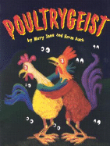 | Auch, Mary Jane and Herm Auch. Poultrygeist. New York:  Holiday House, 2003.  It’s Halloween, and the animals are busy getting their costumes ready. Ralph and Rudy are two very rowdy roosters. They always seem to be making noise- even when they try to be quiet. But, the appearance of a mysterious monster might be just the thing to silence them.
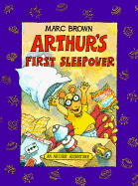 | Brown, Marc. Arthur’s First Sleepover. Boston: Little, Brown  and Company, 1994.  Just as Arthur is getting ready for his very first sleepover party, someone in town spots a spaceship. Arthur and his friends are excited for the sleepover, but also nervous about possibly meeting aliens. D.W. even loans Arthur her camera just in case he sees anything. Is D.W. being thoughtful or is she up to trouble?
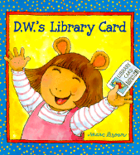 | Brown, Marc. D.W.’s Library Card. Boston: Little, Brown and  Company, 2001.  D.W. can’t wait to get her very own library card and check out whatever books she wants. All she needs to do is learn how to write her full name. After lots of practice and mashed potatoes, D.W. finally gets her card. Unfortunately, the book she wants is already checked out. Will D.W. be patient enough to wait for the book to be returned?
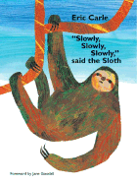 | Carle, Eric. “Slowly, Slowly, Slowly,” said the Sloth. New York:  Philomel Books, 2002.  Slow down- why are you reading so fast? Sloths’ have one speed- SLOW. Don’t confuse their slowness for laziness though. Take a break from your fast paced life to enjoy this book.
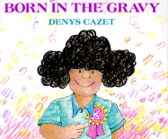 | Cazet, Denys. Born in the Gravy. New York: Orchard Books,  1993.  Today is Margarita’s first day of kindergarten. To celebrate, her papa takes her out for an ice cream cone. As they eat their treats, the little Mexican girl tells her father all about her exciting day and her interesting classmates.
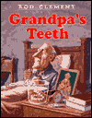 | Clement, Rod. Grandpa’s Teeth. Sydney: Harper Collins  Publishers, 1997.  Oh no! Grandpa’s teeth are missing. The police have the entire town under investigation. Everyone with teeth is a suspect in this incredibly funny mystery that will have you laughing out loud. You won’t be able to help but smile as you read. Hey, are those teeth really yours?
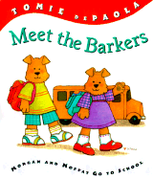 | DePaola, Tomie. Meet the Barkers: Morgan and Moffat Go to  School. New York: G. P. Putnam’s Sons, 2001.  The time has come for the Barker twins to go to school, and they are both so excited. During the first few days, Moffie earns lots of gold stars, but she doesn’t seem to be making any friends. Morgan, on the other hand, makes a friend on the very first day. Can Morgan help his sister to see that there is more to school than being first at everything?
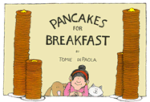 | DePaola, Tomie. Pancakes for Breakfast. San Diego: Harcourt  Brace Jovanovich, 1978.  In this wordless book, a lady wakes up early one morning. Pancakes would be the perfect breakfast, she thinks. Unfortunately, making pancakes may not be as easy as you think. With the help of a few friendly neighbors and hard work, it looks like she may get the meal she craves.
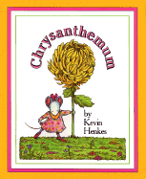 | Henkes, Kevin. Chrysanthemum. New York: Greenwillow  Books, 1991.  Chrysanthemum always loved her name. She thought it was absolutely perfect. That is until she went to school. The children all made fun of her. Will she ever be able to appreciate her name again? Maybe Mrs. Twinkle, the music teacher, can help.
 | Henkes, Kevin. Wemberly Worried. Hong Kong: Greenwillow  Books, 2000.  Wemberly is a sweet little mouse who worries about EVERYTHING. She even worries about her doll Petal. Her family is worried that she worries too much. Now, Wemberly faces the biggest worry of them all- school. (Don’t worry, everything turns out just fine.)
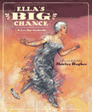 | Hughes, Shirley. Ella’s Big Chance: A Jazz-Age Cinderella.  New York: Simon & Schuster Books for Young Readers, 2003.  Tired of the same old Cinderella stories? Then, here’s one with a bit of a twist. It’s the 1920s, and Ella Cinders works in her father’s dress shop. She has a hideous stepmother and two terrible step sisters. You know the basic story about the ball, the fairy godmother, and the glass slipper. What you don’t know is the surprise at the end of this version of the tale!
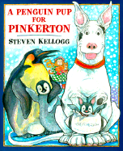 | Kellog, Steven. A Penguin Pup for Pinkerton. New York: Dial  Books for Young Readers, 2001.  After Emily comes home from school talking about penguins and their babies, her dog Pinkerton begins dreaming of adopting his very own penguin. Lost in his dream, Pinkerton mistakes a football for an egg and becomes obsessed with caring for it.
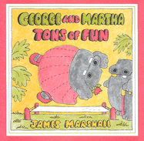 | Marshall, James. George and Martha, Tons of Fun. Boston:  Houghton Mifflin Company, 1980.  George and Martha are the best of friends, most of the time. These five stories about two hippos celebrate both the misunderstandings and the laughter that only true friends can share.
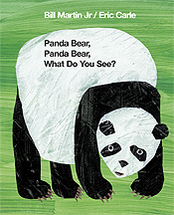 | Martin, Bill Jr. Panda Bear, Panda Bear, What Do You See?.  Illustrated by Eric Carle. New York: Henry Holt and Company, 2003.  If you enjoyed Brown Bear, Brown Bear, What Do you See? then you will love this book. Endangered animals fill the pages of this storybook and a dreaming child can see them all. Within these pages are all kinds of animals- everything from spider monkeys to macaroni penguins.
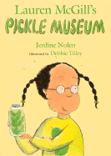 | Nolen, Jerdine. Lauren McGill’s Pickle Museum. Illustrated by  Debbie Tilley. San Diego: Silver Whistle, 2003.  Lauren McGill loves pickles. Gerkins, dills, sweet- you name it, she’ll eat it. She loves pickles so much that she even dresses like one! When Mrs. Munz, her teacher, announces that the class will be taking a field trip to a pickle factory, Lauren is ecstatic. This is the trip of her dreams! But, when a pickle disaster ruins their trip, will Lauren lose her passion for pickles?
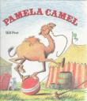 | Peet, Bill. Pamela Camel. Boston: Houghton Mifflin Company,  1984.  Pamela Camel belongs to the circus. Everyone insults her and calls her awful names. One day, Pamela decides she’s had enough and leaves the circus. After doing something very brave, Pamela goes from circus flop to star of the big top.
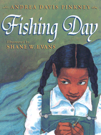 | Pinkney, Andrea Davis. Fishing Day. Illustrated by Shane W.  Evans. New York: Hyperion Books for Children, 2003.  Mama and Reenie, who are black, love to go fishing down at the Jim Crow River. Mr. Troop and his son Pigeon, who are white, come there to fish so they can eat. In all the time they’ve fished at the same river, these two families have never spoken to each other. Will they ever be able to look past the color of their skins and enjoy a nice day of fishing together?
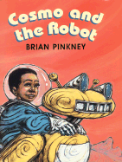 | Pinkney, Brian. Cosmo and the Robot. Greenwillow Books,  2000.  Max lives on Mars. His robot, Rex, breaks and has to be taken to the dump. Max’s parents buy him a snazzy solar system utility belt with ten supersonic attachments. Max’s sister Jewel thinks the belt is dumb, but when she needs her brother’s help, will it be just the thing to save the day?
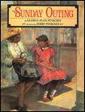 | Pinkney, Gloria Jean. The Sunday Outing. Illustrated by Jerry  Pinkney. New York: Dial Books for Young Readers, 1994.  Ernestine loves going to the railroad station each Sunday with her aunt, Odessa. Even though her friends tell her she’ll never really get to ride on a train, Ernestine can’t help but believe that her dream will one day come true. When her relatives down south invite her for a visit, she may actually get her chance.
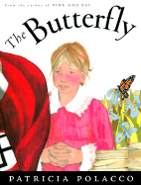 | Polacco, Patricia. The Butterfly. New York: Philomel Books,  2000.  This is the story of Monique, a young girl living in Nazi occupied France. One night, Monique thought a ghost was in her room, but soon she learns that Sevrine is not a ghost at all. Monique discovers that her maman has been keeping a dangerous secret- she has been hiding Jews in the basement!
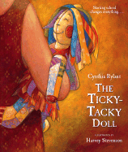 | Rylant, Cynthia. The Ticky-Tacky Doll. Illustrated by Harvey  Stevenson. San Diego: Harcourt, Inc., 2002.  A little girl has a tough time starting school without her favorite doll. She can’t eat or learn her numbers and letters without her ticky-tacky friend by her side, but toys are not allowed to go to school. Luckily, Grandmama knows just how to help her.
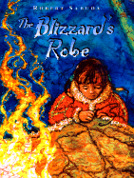 | Sabuda, Robert. The Blizzard’s Robe. New York: Atheneum  Books for Young Readers, 1999.  The People Who Fear the Winter Night are so excited when the mighty Blizzard’s robe is destroyed. This means he can trouble them no more. A young girl named Teune is responsible for ending his terrible visits, but instead of feeling like a hero, she feels horrible. Blizzard begs her to create a new robe in exchange for a special gift. But, once Teune makes it, will Blizzard keep his end of the deal?
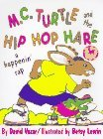 | Vozar, David. M.C. Turtle and the Hip Hop Hare: A Nursery  Rap. Illustrated by Betsy Lewin. New York: Double Day Books for Young Readers, 1995.  This here’s the story of a racing pair,  M.C, Turtle and Hip Hop Hare.  Or, better known to you and me  As the tortoise and the hare- that old story.

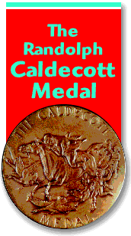

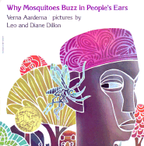  1976 | Aardema, Verna. Why Mosquitoes Buzz in People’s Ears.  Illustrated by Leo and Diane Dillon. New York: Dial Books for Young Readers, 1975.  Did you ever wonder why mosquitoes buzz in people’s ears? When mother owl refuses to wake the sun, King Lion calls a meeting to find out why. The result is a story much like that of the old lady who swallowed the fly.
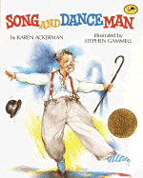  1989 | Ackerman, Karen. Song and Dance Man. Illustrated by  Stephen Gammell. New York: Alfred A. Knopf, 1988.  Supper will be ready in one hour so Grandpa takes his grandchildren up to the attic to entertain them vaudeville style until it is ready. As he taps, tells jokes, sings, and puts on costumes, the grandchildren get to see what life was like before T.V. - during the song and dance days.
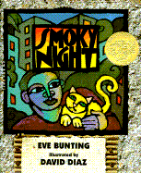  1995 | Bunting, Eve. Smoky Night. Illustrated by David Diaz. San  Diego: Harcourt Brace & Company, 1994.  The Los Angeles riots were a time of looting, vandalism, and racial tension. In the middle of all this smoky chaos, two cats teach their owners a very important lesson about putting aside differences and learning to get along.
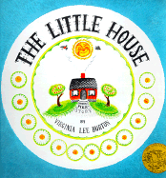  1943 | Burton, Virginia Lee. The Little House. Boston: Houghton  Mifflin Company, 1942.  The little house loved to watch the seasons change, but as the seasons changed so did the world around her. As time passes, the little house goes from living in the country to living in the hustle and bustle of the city all while staying put.
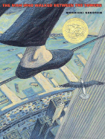  2004 | Gerstein, Mordicai. The Man Who Walked Between the  Towers. Brookfield: Roaring Brook Press, 2003.  When we think about the World Trade Center many images come to people’s minds- the NY skyline, September 11th, a high wire walker…what? This book tells the true story of Phillippe Petit, a French aerialist, who actually walked between the two towers on a tightrope in 1974.
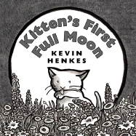  2005 | Henkes, Kevin. Kitten’s First Full Moon. Greenwillow Books,  2004.  Poor kitten! Curiosity really does get the cat in this delightful tale about a cat and her quest for a little bowl of milk. The striking black and white drawings and kitten’s persistent attempts to fill her hungry belly will make you laugh out loud.
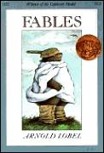  1981 | Lobel, Arnold. Fables. New York: Scholastic, Inc., 1980.  I could tell you that I know it is great, but “knowledge will not always take the place of simple observation.” So, check out this book of fables for yourself.
  1991 | Macaulay, David. Black and White. Boston: Houghton Mifflin  Company, 1990.  Is this one story or four? Is it about cows? Or commuters? Or trains? I’m so confused, or maybe I’m not. This story is definitely not black and white, or is it?
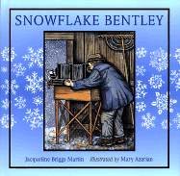  1999 | Martin, Jacqueline Briggs. Snowflake Bentley. Illustrated by  Mary Azarian. Boston: Houghton Mifflin Company, 1998.  This is the biography of Wilson Bentley. From a young age, Wilson was amazed by the beauty of snow and ice. He taught himself to be a scientist and photographer, and eventually, grew up to be a world famous authority on snowflakes.
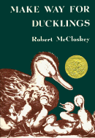  1942 | McCloskey, Robert. Make Way for Ducklings. New York:  Viking Press, 1941.  The mallards are on the move! Like any good parents, Mr. and Mrs. Mallard just want a safe place to raise their family. So, the people of Boston will have to make way for this delightful family of ducks.
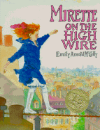  1993 | McCully, Emily Arnold. Mirette on the High Wire. New York:  G.P. Putnam’s Sons, 1992.  When a famous wire walker named the Great Beliini stays at Mirette’s mother’s boarding house, Mirette can’t help but be curious about him and his strange talent. Curiosity turns to determination when Mirette begs him to teach her how to do it too. Why has Belinni stopped in the first place? Does Mirette have what it takes to be a wire walker? This is a delightful story about conquering fears and believing in yourself.
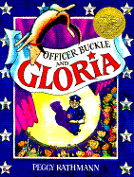  1996 | Rathmann, Peggy. Officer Buckle and Gloria. New York: G. P.  Putnam’s Sons, 1995.  “Never eat mayonnaise that’s been sitting in the sun” is just one of the many safety tips that Officer Buckle has to share. But, no one in Napville will listen… until Gloria the police dog begins accompanying him to his talks. Suddenly people are begging to hear his tips as long as he will “please bring that dog.”
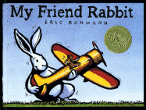  2003 | Rohmanh, Eric. My Friend Rabbit. Brookfield: Roaring Book  Press, 2002.  Have you ever had a friend? A really good friend? A friend who always wants to make you happy? Well, Rabbit is just that kind of friend to mouse. He always means well, but where ever Rabbit goes, trouble seems to follow.
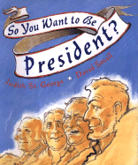  2001 | St. George, Judith. So You Want to be President?. Illustrated  by David Small. New York: Philomel Books, 2000.  So you want to be president? Well, you may already be on your way. As you find out some of the qualities and characteristics of these leaders, maybe you’ll discover that you have some things in common with them already.
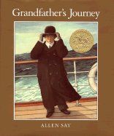  1994 | Say, Allen. Grandfather’s Journey. Boston: Houghton Mifflin  Company, 1993.  Two countries. Two cultures. One family. Anyone who has ever felt homesick will understand how these very real characters feel living in one place and longing to be in another. Grandfather’s Journey takes us on an emotional trip from Japan to California and back again all on a quest for a place that can be called home.
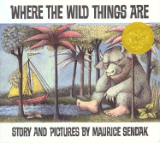  1964 | Sendak, Maurice. Where the Wild Things Are. Harper Collins  Publishers, 1963.  Take a walk on the wild side with Max as he discovers the place where the wild things are and comes to realize that sometimes being loved is better than being king.
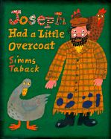  2000 | Taback, Simms. Joseph Had a Little Overcoat. New York:  Viking, 1999.  Joseph had a little overcoat that was falling apart. Instead of throwing it away, he made it into something new- a jacket. When the jacket becomes too shabby, he makes it into something new as well. This book is full of holes- just like Joseph’s little overcoat. Each cut out leads to his next creation. He keeps reinventing his worn out items until eventually he has nothing left. But, don’t worry; Joseph can even make something out of nothing.
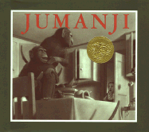  1982 | Van Allsburg, Chris. Jumanji. Boston: Houghton Mifflin  Company, 1981.  Monkeys and lions and rhinos- oh my! Judy and Peter turn a dull afternoon into more excitement than even they can handle with just a roll of the dice. Jumanji is the story of one board game that is anything but boring.
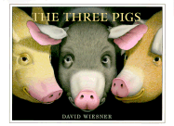  2002 | Wiesner, David. The Three Pigs. New York: Clarion Books,  2001.  Wiesner puts a new spin on an old story. What happens when the three little pigs find a way out of their tired old tale? Well, they invade some of the other tired old stories, make a few friends, and guarantee you, the reader, a good laugh.
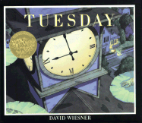  1992 | Wiesner, David. Tuesday. New York: Clarion Books, 1991.  It’s Tuesday, around 8 P.M., and something weird is in the air. Could it be frogs?
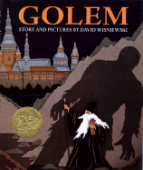  1997 | Wisniewski, David. Golem. New York: Clarion Books, 1996.  The Jewish people are in danger. Rabbi Loew has a dream. Can Golem, the giant made from living clay, protect the Jews? Rabbi Loew is about to find out.
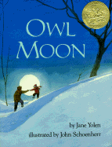  1988 | Yolen, Jane. Owl Moon. Illustrated by John Schoenherr. New  York: Philomel Books, 1987.  When all the world is at home asleep and tucked in cozy beds, a father and daughter spend a quiet adventure together under the owl moon. When you go owling, you have to be quiet. When you go owling, you have to make your own heat. When you go owling, what you need more than anything else is hope.
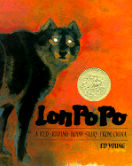  1990 | Young, Ed. Lon Po Po: A Red-Riding Hood Story from China.  New York: Philomel Books, 1989.  Three young Chinese girls have to be very clever and think fast to protect themselves from the wolf who poses as their grandmother come to visit when their mother goes out to visit their real Po Po.
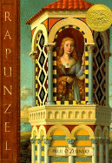  1998 | Zelinsky, Paul O. Rapunzel. New York: Dutton Children’s  Books, 1997.  Rapunzel, Rapunzel, let down your hair. Zelinsky offers a different point of view than the traditional tale. The woman who imprisons Rapunzel is not the mean witch of old, but rather a woman who longs to be a mother and protect the child she has been given.

ALA
Notable Books

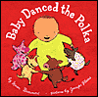 | Beaumont, Karen. Baby Danced the Polka. Illustrated by  Jennifer Plecas. New York: Dial Books for Young Readers, 2004.  Its baby’s naptime, and Ma and Pa have chores to do. Baby is not tired, not tired at all. Baby doesn’t want to sleep; he wants to dance. Will Ma and Pa ever get him to go to bed?
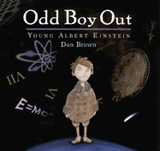 | Brown, Don. Odd Boy Out: Young Albert Einstein. Boston:  Houghton Mifflin Company, 2004.  From fat baby, to angry child, to the discovery of E= mc², this story chronicles the life of Albert Einstein. Here the focus is on the person, who went through life mostly misunderstood, rather than on his theories and accomplishments.
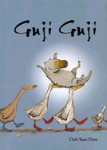 | Chen, Chih-Yuan. Guji Guji. La Jolla: Kane/Miller Book  Publishers, 2004.  One day a strange egg rolls into Mother Duck’s nest. She was so busy reading that she didn’t even notice. Soon, the eggs hatch. The babies are each unique, but one really stands out- Guji Guji, who isn’t a duck at all. He is a crocodile, but he doesn’t know it. One awful day, Guji Guji meets three really bad crocodiles who are up to no good. And, it’s up to him to face the truth about who he really is and to save the only family he’s ever know.
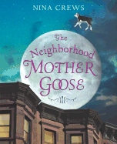 | Crews, Nina. The Neighborhood Mother Goose. New York:  Greewillow Books, 2004.  Old school rhymes come into modern times, as new life is breathed into familiar nursery rhymes. Cleverly chosen photographs of city life accompany each verse in style.
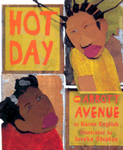 | English, Karen. Hot Day on Abbott Avenue. Illustrated by  Javaka Steptoe. New York: Clarion Books, 2004.  It is the hottest day of the summer, and instead of finding ways to stay cool, Kishi and Renee are in the middle of a heated battle. They are so mad at each other they have declared it a “best-friend-breakup day.” Each swears to stay mad forever, but maybe, just maybe, a game of double dutch can bring them back together.
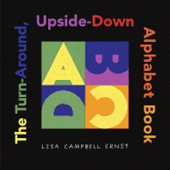 | Ernst, Lisa Campbell. The Turn-Around, Upside-Down  Alphabet Book. New York: Simon & Schuster Books for Young Readers, 2004.  This is a rather unusual alphabet book. Each letter magically becomes three different objects with just a turn of the book.
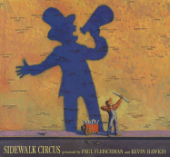 | Fleischman, Paul and Kevin Hawkes. Sidewalk Circus.  Cambridge: Candlewick Press, 2004.  “COMING SOON…WORLD-RENOWNED…GARIBALDI CIRCUS!!!!” beckon the signs around town. One young girl seems to have a front row seat as she waits at a bus stop watching the circus of life around her.
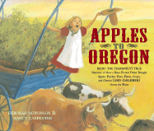 | Hopkinson, Deborah and Nancy Carpenter. Apples to Oregon:  Being the (Slightly) True Narrative of How a Brave Pioneer Father Brought Apples, Peaches, Pears, Plums, Grapes, and Cherries (And Children) Across the Plains. New York: Antheneum Books for Young Readers, 2004.  Papa decides its time to move the family from Iowa to Oregon, but he can’t bear to leave his fruit trees behind. So, this brave pioneer packs up his peaches, pears, plums, grapes, apples, cherries, and children and begins a grand journey across the plains. Delicious, his daughter, helps save the day on more than one occasion in this delightful tall tale.
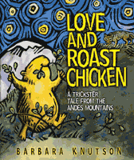 | Knutson, Barbara. Love and Roast Chicken:: A Trickster Tale  from the Andes Mountains. Minneapolis: Carolrhoda Books, 2004.  Cuy the Guinea Pig just wants something to eat. Tío Antonio the Fox always seems to be hungry too- for guinea pigs! Cuy has to be crafty and come up with some clever plans in order to avoid being eaten. Tío Antonio may not be able to beat him, but Cuy may have met his match in the farmer.
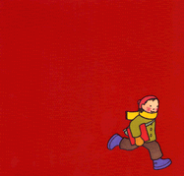 | Lehman, Barbara. The Red Book. Boston: Houghton Mifflin  Company, 2004.  Books hold many adventures. You can travel to tropical islands and peek in the windows of fabulous city skyscrapers in this little red book. Enjoy the journey that only a good book holds in this picture story about a magical red book.
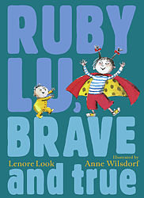 | Look, Lenore. Ruby Lu, Brave and True. Illustrated by Anne  Wilsdorf. New York : Atheneum Books for Young Readers, 2004.  Ruby Lu is famous on 20th Avenue South. This Asian-American (almost) eight year old kid has got good days and not-so-good days that will make you laugh out loud As she deals with her baby brother Oscar, performs her own magic show, and goes to Chinese school, . you’ll never be bored with Ruby. The best thing about Ruby Lu, Brave and True is everything!
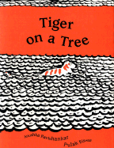 | Ravishankar, Anushka and Pulak Biswas. Tiger on a Tree.  New York: Farrar, Straus and Giroux, 1997.  A man looks up and what does he see? An orange and white tiger is on the tree. He runs and tells his friends the news. How should they handle this? What should they do? Will they capture the tiger on the tree or will they be kind and set him free?
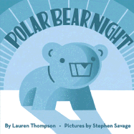 | Thompson, Lauren. Polar Bear Night. Illustrated by Stephen  Savage. New York: Scholastic Press, 2004.  Join a polar bear cub as it wakes up and leaves the den to explore the magical night. An amazing star show illuminates many other sleeping animals and eventually guides the cub back to sleep. What a wonderful bed time tale!
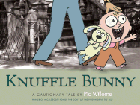 | Willems, Mo. Knuffle Bunny. New York: Hyperion Books for  Children, 2004.  Trixie, Daddy, and Knuffle Bunny go to the laudromat one day. On the way home, Trixie realizes that some bunny special has been left behind. She tries to explain this to Daddy, but he just doesn’t seem to understand. Will Trixie ever see her Knuffle Bunny again?

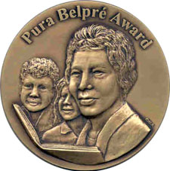

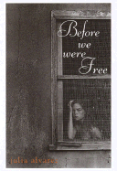  2004  Author Award | Alvarez, Julia. Before We Were Free. New York: Alfred A.  Knopf, 2002.  Anita is turning twelve years old, and her world is turning upside down. It is the early 1960’s and the terrible Trujillo is el jefé in the Dominican Republic. As the knowledge of her family’s involvement in the underground movement to overthrow the General comes to light, Anita wonders if she will be brave enough to survive becoming a señorita, falling in love, and staying alive in the midst of all these secrets.
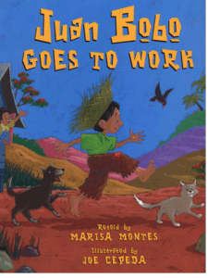  2002  Illustrator Honor | Montes, Marisa. Juan Bobo Goes to Work: A Puerto Rican  Folktale. Illustrated by Joe Cepeda. New York: Morrow Junior Books, 2000.  Juan Bobo tries very, very hard to do things right. Unfortunately, Juan is a fool and always manages to get everything mixed up. He is a hard worker, but he has no common sense. You’ll laugh out loud at all of Juan’s blunders. No wonder Juan Bobo means Simple John!
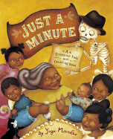  2004  Illustrator Award | Morales, Yuyi. Just a Minute: A Trickster Tale and Counting  Book. San Francisco: Chronicle Books, 2003.  Senor Galavera, A.K.A. death, has come for Grandma Beetle. She is not quite ready to go though. She just has one, dos, three, cuatro… things to do and then she will be ready. Will Senor Galavera be willing to wait?
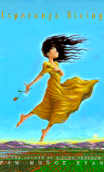  2002 Author Award | Ryan, Pam Muñoz. Esperanza Rising. New York: Scholastic  Press, 2000.  The first twelve years of Esperanza’s life were spent enjoying wealth and ease in Mexico. When a terrible tragedy befalls her family, Esperanza and her mother must leave their old live of luxury behind and move to California. Life in the labor camps is harsh and Mexican farm workers are treated poorly. Will Esperanza be able to survive?
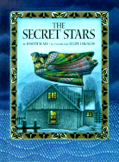  2000  Illustrator Honor | Slate, Joseph. The Secret Stars. Illustrated by Felipe Davalos.  New York: Marshall Cavendish, 1998.  As Pepe and Sila await the arrival of the three kings, they worry that the kings won’t be able to find their way. An ice storm has hidden the stars in the New Mexico sky. Grandmother takes them on a magical journey to show the children the secret stars that will guide the kings.
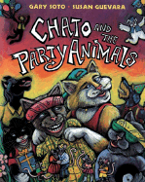  2002  Illustrator Award | Soto, Gary. Chato and the Party Animals. Illustrated by Susan  Guevara. New York: G. P. Putnam’s Sons, 2000.  Chato is one cool vato! When he finds out his homecat Novio Boy has never had a birthday party, he decides to throw him a big surprise party. Unfortunately, Chato seems to have forgotten to invite the guest of honor. ¡Qué tonto!




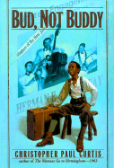  2000 Author Award  2000 Newbery Winner | Curtis, Christopher Paul. Bud, Not Buddy. New York :  Delacorte Press, 1999.  Are you searching for a feel good book with the perfect mix of laughter and adventure? Here it is. Ten year old Bud is tired of the bad treatment he’s received in foster care. He’s even got a list of rules he’s made up just to help himself survive. With nothing but a beat up suitcase and some “clues” his mother left him, Bud sets out on the lam. As Bud journeys from Flint to Grand Rapids to find his father, he may just find himself along the way too.
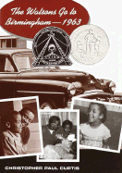  1996 Honor  1996 Newbery Honor | Curtis, Christopher Paul. The Watsons Go to Birmingham-  1963. New York: Delacorte Press, 1995.  The Watson family is weird. There are no two ways about it. Their car, the brown bomber, looks like a turd on wheels. Kenny, our narrator, looks at everybody sideways so that they won’t notice his lazy eye. Older brother Byron thinks he’s so hot, he runs into a little problem kissing himself in a frosty car mirror. This story tells about the wacky events of their family vacation from Flint, Michigan to Birmingham, Alabama. You’ll laugh. You’ll cry. You’ll love every page!
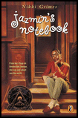  1999 Honor | Grimes, Nikki. Jazmin’s Notebook. New York: Puffin Books,  1998.  Jazmin has had a hard life. Her daddy is dead, her mom is in the hospital, and all she has left is her older sister CeCe. The two do the best they can living in a cramped apartment in Harlem. Life is not all bad though because Jazmin has her dreams, her poetry, and her notebook to get her through.
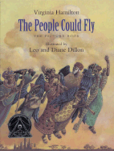  2005 Honor | Hamilton, Virginia. The People Could Fly: The Picture Book.  Illustrated by Leo and Diane Dillon. New York: Alfred A. Knopf, 2004.  Long ago there were some people in Africa who knew magic. Their magic gave them great wings and allowed them to fly. One day the people were captured and forced into slavery. After many long hot and backbreaking days and beatings, these magical people, these people who could fly, find that the time has come to rise again.
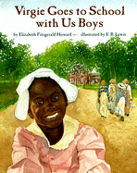  2001 Honor | Howard, Elizabeth Fitzgerald. Virgie Goes to School with Us  Boys. Illustrated by E.B. Lewis. New York: Simon & Schuster Books for Young Readers, 2000.  After the war, the Quakers opened a school for black students. Virgie’s older brothers have been attending. Since she’s free too, doesn’t Virgie have a right to go to school and learn too? Her brothers think she’s too little, but Virgie won’t take no for an answer.
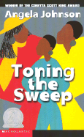  1994 Author Award | Johnson, Angela. Toning the Sweep. New York: Orchard  Books, 1993.  Emmie has gone to visit her Grandmama Ola every summer for the past twelve years. This trip is different though, when she leaves the desert, Ola will be coming with her back to Cleveland to receive medical treatment. As Ola and mama pack up the house, Emmie picks up a camcorder and sets to taping the people who have become Ola’s closest friends. Through her recordings, she learns more about her family than she ever expected.
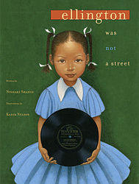  2005 Illustrator Award | Shange, Ntozake. Ellington was not a Street. Illustrated by  Kadir Nelson. New York: Simon & Schuster Books for young Readers, 2004.  Shange’s poem Mood Indigo is warmly accompanied by Nelson’s paintings in this beautiful book. Readers will feel as if they have been taken back in time as the narrator remembers her childhood days when great men like Paul Robeson, “Dizzy” Gillespie, and Duke Ellington used to gather together. Each page is a celebration of these men as they once were- real and important, not just faded memories or names in history books.





2005 Nominees

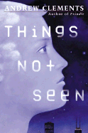 | Clements, Andrew. Things Not Seen. New York: Philomel  Books, 2001.  Imagine waking up, going into the bathroom, looking into the mirror, and seeing nothing. That’s right, you’re not there. You can hear yourself. You can feel yourself. You just can’t see yourself, and neither can anyone else. This is what happens to fifteen year old Bobby.
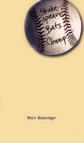 | Koertge, Ronald. Shakespeare Bats Cleanup. Cambridge:  Candlewick Press, 2003.  Kevin is fourteen years old. He is baseball star. So, what does his writer father give him when Kevin gets mononucleosis and can’t play ball for a while? A journal, just what he always wanted. Yeah, right! Boredom begins to set in and Kevin decides to read one of his dad’s poetry books, since there is nothing else to do. Next, he tries his hand a writing a few of his own poems, just for fun, of course. Could it be that Kevin is actually starting to like this stuff?
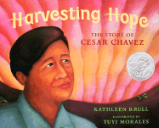 | Krull, Kathleen. Harvesting Hope: The Story of Cesar Chavez.  Illustrated by Yuyi Morales. San Diego: Harcourt, Inc., 2003.  Follow Cesar Chavez as he grows from a boy of ten to a memorable man of thirty-eight. When his family became migrant workers in California, Cesar could not believe how badly workers were treated. As a child, he did not like conflict at all. By the time he was in his early twenties, Cesar realized that some conflicts you just can’t run from. Sometimes you have to fight back. ¡Viva la Causa!
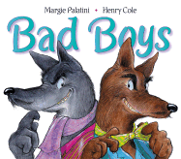 | Palatini, Margie. Bad Boys. Illustrated by Henry Cole. New  York: Katherine Tegen Books, 2003.  Willy and Wally are bad, really, really bad. In fact, these two shady wolves pride themselves on their badness. When the two disguise themselves as sheep to try and catch a lamb chop diner, could it be that they are the ones having the wool pulled over their eyes?
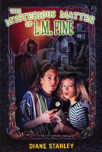 | Stanley, Diane. The Mysterious Matter of I.M. Fine. New  York: Harper Collins Publishers, 2001.  Strange things have been happening to kids at Frannie and Beamer’s school. First, Jelly Worms become the “in” thing to have at lunch. Next, the students start experiencing exploding headaches that last three days. The weird thing is that it all only happens to certain kids. Only the kids who read the Chillers books by the popular author I. M. Fine seem to be affected. There must be some connection between the books and the bizarre happenings. Can Frannie and Beamer figure it out before it’s too late?
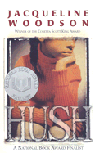 | Woodson, Jacqueline. Hush. New York: Speak, 2002.  What if you had to move away from everything that you know? What if you had to change your name forever? When twelve year old Toswiah Green’s father testifies against a fellow police officer, her family must enter the witness protection program. They must change their identities and move to a new city. Will Toswiah ever get used to being Evie Thomas?




Intermediate Fiction

 | Hahn, Mary Downing. The Old Willis Place. New York:  Clarion Books, 2004.  Twelve year old Diana is tired of the rules. Ever since “the bad thing happened” life, as Diana and Georgie knew it, has changed. Diana decides it’s time to break the rules, despite her brother’s warnings. But, breaking the rules has consequences. How will they survive once the evil spirit locked inside the old Willis place is unleashed?
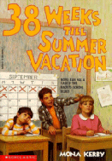 | Kerby, Mona. 38 Weeks till Summer Vacation. Illustrated by  Melodye Rosales. New York: Viking Kestrel, 1989.  38 weeks might seem like a long time to wait for summer vacation, but don’t worry, the time will fly. With skinny Nora Jean Sampson and her friends at R.B. Nolen Elementary School to keep you company the time will fly. I mean, who cares about summer when you have snakes in the girls’ bathroom, a spooky Halloween fun house, and a pizza party in the library to concentrate on?
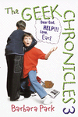 | Park, Barbara. Dear God, Help!!! Love, Earl (The Geek  Chronicles 3). New York: Random House, 2000.  Earl and his friends are sick and tired of being pushed around by the class bully. Determined to get even, the three friends devise an elaborate plot for revenge. You’ll laugh out loud as you cheer on Earl, Rosie, and Max!
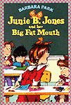 | Park, Barbara. Junie B. Jones and Her Big Fat Mouth.  Illustrated by Denise Brunkus. New York, Random House, 1993.  Monday is Job Day in Junie B.’s kindergarten class. Accidentally, Junie B. shoots off her big fat mouth on the bus and says she has the bestest job of all in mind. Really though, she has no idea what she wants to be when she grows up. How will she get herself out of this mess?
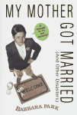 | Park, Barbara. My Mother Got Married (and other disasters).  New York: Random House, 1990.  When Charlie’s parents got divorced, he thought it was the end of the world. Now, things have gotten worse. His mom is remarrying! His new stepfather and his two kids move in, and Charlie even has to share his room. Can things ever go back to the way they used to be?
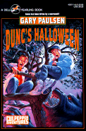 | Paulsen, Gary. Dunc’s Halloween. New York: Dell, 1992.  Dunc and Amos are best friends. This Halloween they have planned out a route to get enough candy to last the whole year. While they are out practicing for the big night, they get attacked by a big werewolf. Amos gets bitten, ever so slightly, by the monster. The next day, Dunc begins to suspect that they have a big problem on their hands when Amos starts chasing cats, panting, and growling. Has Amos been turned into a werepuppy?
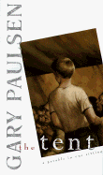 | Paulsen, Gary. The Tent: A Parable in One Sitting. San Diego:  Harcourt Brace & Company, 1995.  14 year old Steven thinks his father, Corey, must be joking when he suggests going on the road and preaching. They don’t even go to church. Tired of living in a trailer and being poor, Corey is not kidding. The two set off on a journey preaching the Lord’s word with a stolen bible and becoming richer and richer each day. But, will they be able to live with the guilt?
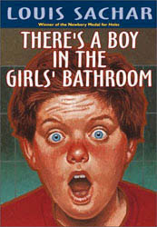 | Sachar, Louis. There’s a Boy in the Girl’s Bathroom. New  York: Scholastic Inc., 1987.  Bradley Chalkers is not only the oldest kid in the 5th grade, he’s also the meanest. No one likes him- not even his teacher. Things change when a new kid and a new counselor come to school. Bradley may finally learn how to make some friends if only he can learn to believe that he can be good.
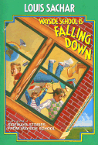 | Sachar, Louis. Wayside School is Falling Down. Illustrated by  Joel Schick. New York: Avon Books, 1989.  Join Mrs. Jewls, Louis the yard teacher, and 29 wacky students for 30 short, but hilarious tales. Trouble and adventure are a part of every day at the Wayside School. This book will have you falling down with the sillies.

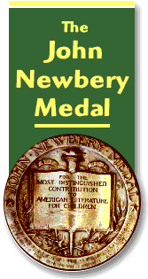

  2003 | Avi. Crispin: The Cross of Lead. New York: Hyperion  Paperbacks for Children, 2002.  The time is fourteenth century England, and an orphaned peasant boy has been falsely accused of theft and murder. Known only as “Asta’s son”, the boy soon learns that his given name is actually Crispin. He also learns that he is in great danger and realizes he must flee his village if he hopes to live. He meets a juggler along the way who holds a dark secret which may just be connected to Crispin’s past.
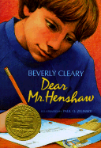  1984 | Cleary, Beverly. Dear Mr. Henshaw. Illustrated by Paul O.  Zelinsky. New York: Avon Books, Inc. 1983.  It all began in the 2nd grade when Leigh Botts (boy) wrote a letter to his favorite author, Mr. Boyd Henshaw. Over the years, Mr. Henshaw and Leigh become pen pals of sorts. Under the guidance of Henshaw, Leigh learns to deal with his parents’ divorce, to handle the trials and tribulations of growing up, and how to become a writer.
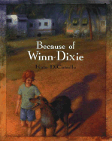  2001 Honor Book | DiCamillo, Kate. Because of Winn Dixie. Cambridge:  Candlewick Press, 2000.  This is the story of ten year old Opal and her funny, ugly, best friend of a dog. When Opal discovers the dog at a local grocery store, she knows he is one of the less fortunate. Her daddy always told her to help the less fortunate, so she has no choice but to become Winn Dixie’s friend. Lucky for Winn Dixie, Opal just happens to need a friend too.
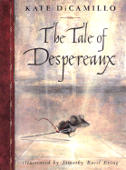  2004 | DiCamillo, Kate. The Tale of Despereaux: Being the Story of a  Mouse, a Princess, Some Soup, and a Spool of Thread. Illustrated by Timothy Basil Ering. New York: Scholastic Inc., 2003.  What kind of story can you possibly get when the main characters are a princess named Pea, a rat named Roscuro who craves light rather than dark, a frumpy cauliflower eared servant girl named Miggery Sow, and a mouse with an unusually small body and unusually large ears named Despereuax? Well, reader, an interesting journey waits within the pages of this book. It is up to you to join in.
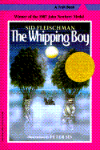  1987 | Fleischman, Sid. The Whipping Boy. Illustrated by Peter Sis.  Mahwah: Troll Associates, 1986.  There once was a prince known as Prince Brat, because that is what he was- a BRAT! It was forbidden in the land to spank the heir to the royal throne, so an orphan boy named Jeremy was hired to take the whippings for him. Both the whipping boy and the prince longed to run away, for different reasons of course. This is the story of the adventure that changed both of their lives forever.
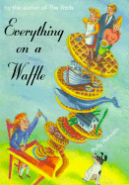  2002 Honor Book | Horvath, Polly. Everything on a Waffle. New York: Farrar  Straus Giroux, 2001.  “Haven't you ever just known something deep in your heart without reason?" Primrose Squarp’s parents have disappeared at sea. Everyone else is certain they are dead, but Primrose knows deep in her heart that they are still alive. While she waits for them to come back, she learns a lot about life and cooking from her Uncle Jack, who takes her in, and Miss Bowzer, who serves everything in her restaurant on a waffle.  There are even real recipes included in the book!
  2005 | Kadohata, Cynthia. Kira-Kira. New York: Atheneum Books for  Young Readers, 2004.  Lynnie and Kate are sisters and best friends. This story follows their pain as they move from comfortable Iowa to Georgia where they are one of six Japanese families. Lynnie teaches her little sister about kira-kira, life, and planning for the future. When Lynnie becomes terminally ill, it is up to Katie to hold tight to the lessons her sister has taught her.
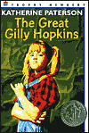  1979 Honor Book | Paterson, Katherine. The Great Gilly Hopkins. New York:  Harper Trophy, 1978.  Gilly has been in more foster homes than she can count. No one seems to be able to manage her wild behavior. Maime Trotter and her strange family are sure going to try though. Convinced that she can end her foster care days and live with her real mother, Gilly devises a scheme. How will she handle learning that life doesn’t always turn out the way you plan?
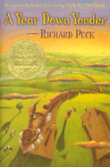  2001 | Peck, Richard. A Year Down Yonder. New York: Scholastic,  Inc., 2000.  Grandma Dowdel is a big woman with an even bigger reputation. When Mary Alice is sent to go live with her for a year, she has no idea what she’s in for. Turns out, a year down yonder is full of more adventure and laughter than she could ever have imagined. The story of these larger-than-life characters will keep you in hysterics!
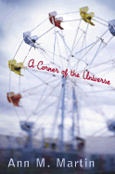  2003 Honor Book | Martin, Ann M. A Corner of the Universe. New York:  Scholastic Press, 2002.  Hattie has an uncle she never even knew existed. Now that his “school” (an institution for the mentally disabled) is closing, Uncle Adam will be coming home. Adam acts more like a child than an adult, which is hard for certain members of the family to accept. With a carnival in town, a new found uncle, and a brand new friend, this will be one unforgettable summer. Join Hattie as she learns to find her own little corner of the universe.
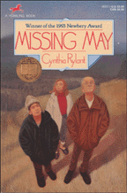  1993 | Rylant, Cynthia. Missing May. New York: Orchard Books,  1992.  Twelve year old Summer’s beloved Aunt May has died. That’s hard enough to deal with. When Ob, May’s husband, senses her presence, no one else does. Things get even more difficult. Next, Cletus Underwood, a kid from school who also believes in the spirit world, becomes involved. Will Summer be enough to keep Ob grounded in the world of the living? Or, will missing May be too much for them all to bear?
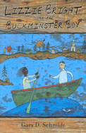  2005 Honor Book | Schmidt, Gary D. Lizzie Bright and the Buckminster Boy. New York: Clarion Books, 2004.  Turner Buckminster is the minister’s son and no one will let him forget it. When his family moves to Phippsburg, Maine, he learns quickly that he doesn’t fit in. Enter Lizzie Bright Griffin, a sassy girl from Malaga Island, a community founded by slaves. The two become fast friends much to the towns’ people’s disapproval. Turner and Lizzie are forbidden to see each other. Warning: Read this book with a box of tissues on hand!
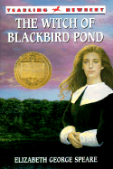  1959 | Speare, Elizabeth George. The Witch of Blackbird Pond. New  York: Bantam Doubleday Dell Books for Young Readers, 1958.  Kit Tyler leaves her home in Barbados and boards a ship for Connecticut Colony. She has no idea how different life in America will be for her. As Kit struggles to fit in, she makes many mistakes and a few close friends. One of which is suspected on being an actual witch. Will Kit ever fit in? Will she ever be able to call Connecticut Colony home?



Fairy Tales

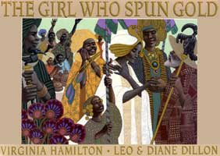 | Hamilton, Virginia. The Girl Who Spun Gold. Illustrated by  Leo and Diane Dillon. New York: The Blue Sky Press, 2000.  One day Big King comes riding through and Mama tells him a terrible lie- that her daughter Quashiba can spin gold thread. The king decides to make Quashi his queen. After a year and one day of wedded bliss, he demands that she weave him three rooms of golden things. Queen Quashi doesn’t know what to do. Find out how she gets out of this predicament in this African retelling of Rumpelstiltskin.
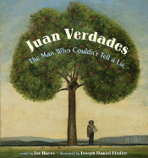 | Hayes, Joe. Juan Verdades: The Man Who Couldn’t Tell a Lie.  Illustrated by Daniel Fiedler. New York: Orchard Books, 2001.  Don Ignacio has the finest apple tree- el manzano real. When his friend don Arturo discovers that don Ignacio allows his employee Juan Verdades to tend to his tree, he is amazed. No employee is that honest to be trusted with such a task. The two amigos make a bet. If don Arturo can find a way to make Juan lie to his boss, then don Ignacio will have to give up his ranch. Can Juan Verdades live up to his name?
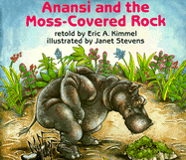 | Kimmel, Eric A. Anansi and the Moss-Covered Rock.  Illustrated by Janet Stevens. New York: Holiday House, 1988.  Anansi the spider finds a strange moss-covered rock in the forest. When Anansi realizes that the rock has special magical powers, he decides to have a little fun tricking some of the other animals. He tricks Lion, Elephant, Giraffe, and many others. But, Little Bush Deer has been watching and has decided that it is time to teach the trickster spider a lesson.
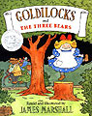 | Marshall, James. Goldilocks and the Three Bears. New York:  Dial Books for Young Readers, 1988.  One day Goldilocks’s mother sent her to buy muffins in the next village. Goldilocks had a habit of being naughty and not following directions. When she decides to disregard some danger signs, she ends up in the middle of the woods at a small cottage owned by three bears. Without knocking or thinking, she lets herself in.
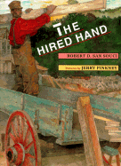 | San Souci, Robert D. The Hired Hand: An African American  Folktale. Illustrated by Jerry Pinkney. New York: Dial Books for Young Readers, 1997.  Young Sam and Old Sam are nothing alike. Young Sam is lazy and shady and thick-headed. When a new hand is hired, Young Sam spends his days ordering him around and spying on him. He discovers that the new hand has an unbelievable talent for healing people. But, when Young Sam tries his hand at healing, things go terribly wrong. Will Young Sam be able to get himself out of this mess?
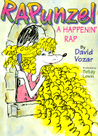 | Vozar, David. RAPunzel: A Happenin’ Rap. Illustrated by Betsy  Lewin. New York: Doubleday Books for Young Readers, 1998.  Kids of all ages will love reading aloud this classical fairytale remix. Fresh lyrical lines and hip-hop rhythms prove that David Volzar is the man when it comes to putting the rap in Rapunzel.

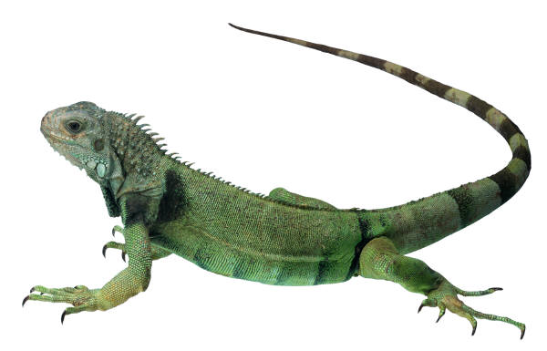
Science and Math

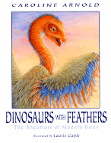 | Arnold, Caroline. Dinosaurs with Feathers: The Ancestors of  Modern Birds. Illustrated by Laurie Caple. New York: Clarion Books, 2001.  Scientist have spent a lot of time comparing dinosaurs with birds. Amazingly enough, the two share many similarities. Could it be that the birds of today are really just tiny dinosaurs?
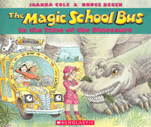 | Cole, Joanna. The Magic School Bus: In the Time of the  Dinosaurs. Illustrated by Bruce Degen. New York: Scholastic Inc., 1994.  It’s visitor’s day and Ms. Frizzle’s classroom has been transformed into dinosaur land. Before the visitors arrive, the whole class is invited to a dinosaur dig site. While there, Ms. Frizzle just can’t resist taking the class back in time on the magic school bus to the Age of Dinosaurs.
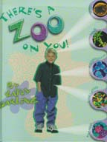 | Darling, Kathy. There’s a Zoo on You. Brookfield: Millbrook  Press, 2000.  When you were first born, there weren’t any microbes on you. Within six hours, there was a zoo on you! True, it sounds creepy, but your personal zoo actually plays an important role in keeping you healthy.
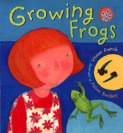 | French, Vivian. Growing Frogs. Illustrated by Alison Bartlett.  Cambridge: Candlewick Press, 2000.  Are you a fan of frogs? Join a little girl and her mom on a frog growing adventure. You’ll discover how frogs develop and how to grow your very own frogs from frog spawn. What are you waiting for? Hop to it, go check out this book!
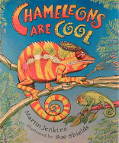 | Jenkins, Martin. Chameleons Are Cool. Illustrated by Sue  Shields. Cambridge: Candlewick Press, 1997.  Want to learn some neat facts about an amazing color changing lizard? For example, did you know that there is a chameleon so small it could balance on the tip of your pinky finger? After reading this, I know you’ll agree that chameleons really are cool!
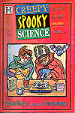 | Markle, Sandra. Creepy Spooky Science. Illustrated by Cecile  Schoberle. New York: Hyperion, 1996.  Want to whip up some blood? How about make it boil? Ever wonder which part of a dead body would rot first? Then this book is the one for you. This collection of over twenty creepy and disgusting experiments will show you a side of science you’ll never forget.
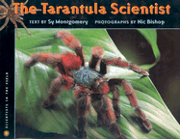 | Montgomery, Sy. The Tarantula Scientist. Photographs by Nic  Bishop. Boston: Houghton Mifflin Company, 2004.  Follow Sam Marshall, a spider scientist, as he studies tarantulas in French Guiana, South America. Sam has never been bitten even though he’s handled hundreds of tarantulas. The pictures are so amazing, and the writing is funny and understandable. Spider lovers won’t be able to resist this up close and personal look at tarantulas.
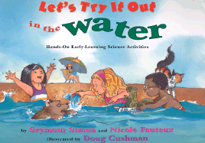 | Simon, Seymour, and Nicole Fauteux. Let’s Try it Out in the  Water: Hands-On Early-Learning Science Activities. Illustrated by Doug Cushman. New York: Simon & Schuster Books for Young Readers, 2001.  Do you love playing in water? Have you ever wondered why some things float and why others sink? Do you like making guesses and thinking like a scientist? If you answered those questions “Yes!”, then this hands on book is the one for you!
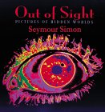 | Simon, Seymour. Out of Sight: Pictures of Hidden Worlds.  New York: Sea Star Books, 2000.  It’s time to see the unseeable. Simon’s collection of photographs will let you in on a secret world of object too tiny or too vast to be seen by the naked eye. View Velcro up close. Peer at plaque. After reading this book, you’ll never skip a trip to the dentist again!
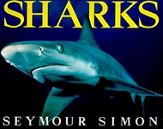 | Simon, Seymour. Sharks. New York: Harper Collins Publishers,  1995.  Did you know that sharks have six senses? That’s right, you read correctly-six! This is just one of the many awesome shark facts you’ll learn in this book. Simon tells the truth about these interesting creatures of the sea, which are often given a very bad rap.
 | Simon, Seymour. Wildfires. New York: Morrow Junior Books,  1996.  Wildfires are a part of the natural cycle of life. They are not good or bad. Simon erases the myth that all forest fires are bad. In this book, you will learn how wildfires begin and how forests can benefit from them.
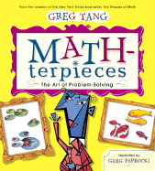 | Tang, Greg. MATH-terpieces: The Art of Problem-Solving.  Illustrated by Greg Paprocki. New York: Scholastic Press, 2003.  Math  + Art History  One really fun way to problem solve  Short poems introduce the works and styles of twelve master artists, as well as, the math concepts of adding and grouping.
 | Wormell, Christopher. Teeth, Tails, & Tentacles: An Animal  Counting Book. Philadelphia: Running Press, 2004.  Readers old and young alike will have fun counting the teeth, tails, and tentacles of a variety of animals. There are lots of interesting things to count in nature, everything from a rhinoceros’ horn to barnacles on a humpback whale. When you’re done counting, you’ll enjoy reading about each of the animals featured in the book.

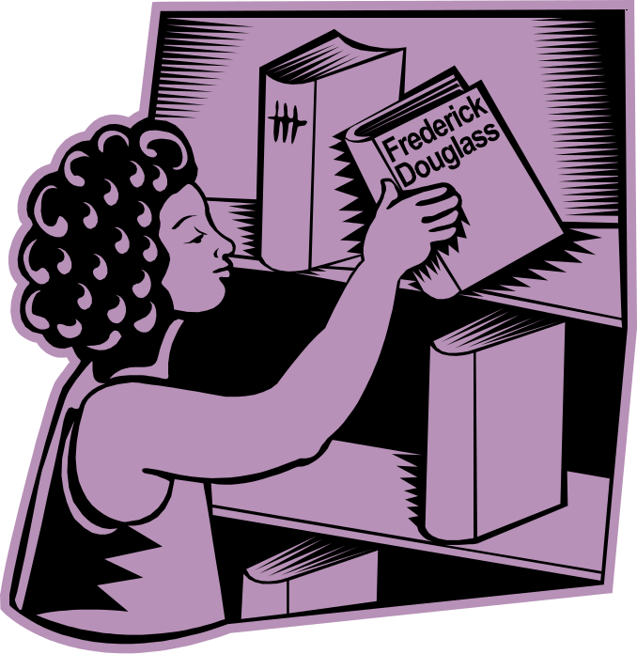
Biography and History

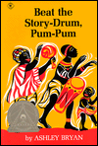 | Bryan, Ashley. Beat the Story-Drum, Pum-Pum. New York:  Antheneum, 1980.  Read to the beat of a different drum. These five folktales from Nigeria are retold with such style and rhythms that you’ll swear you’re actually hearing the story drum.
 | Fradin, Dennis Brindell, and Judith Bloom Fradin. Ida B.  Wells: Mother of the Civil Rights Movement. New York: Clarion Books, 2000.  Ida B. Wells did many amazing things in her life. She helped found the NAACP and fought for women’s rights to name a few. She was brave and spoke out about the things she believed in. Perhaps this is why she is known as the mother of the civil rights movement.
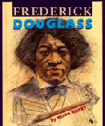 | Kerby, Mona. Frederick Douglas. New York: Franklin Watts,  1994.  Follow the life of Frederick Douglas as he grows from a young slave boy in Talbot County, Maryland, to one of the most famous black men in the world. Despite the fact that he was born a slave, Frederick learned to read and write. Douglas believed that learning to read equaled freedom. Read this book, and you’ll understand exactly what he meant.
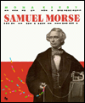 | Kerby, Mona. Samuel Morse. New York: Franklin Watts, 1991.  Did you know that Samuel Morse was once a painter? You may know him better at the inventor of Morse code and the telegraph. You can find out more about his life, experiment with Morse code, and learn how to make your very own telegraph set all by reading this book.
 | Krull, Kathleen. Wilma Unlimited How Wilma Rudolph  Became the World’s Fastest Woman. Illustrated by David Diaz. San Diego: Harcourt Brace & Company, 1996.  They told her she would never walk again. She refused to believe it. She promised herself that she would not only walk, she would run. She was right. Who was she? Wilma Rudolph, the winner of three Olympic gold medals.
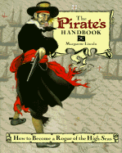 | Lincoln, Margarette. The Pirate’s Handbook: How to Become a  Rogue of the High Seas. New York: Cobblehill Books, 1995.  Are ye looking for some practical advice on how to become a fierce and terrific pirate? Then consider this book marked with an X. Within the pages of this handbook for pirates you’ll find more facts about real life pirates than could fill a treasure chest. You’ll also discover many fashion tips, tests for scurvy, recipes, and activities with easy to follow directions. Landlubber, what are you waiting for? Let the fun begin!
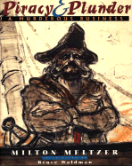 | Meltzer, Milton. Piracy &Plunder: A murderous Business.  Illustrated by Bruce Waldman. New York: Dulton Children’s Books, 2001.  Here be the true and terrible tales of pirates and their dirty business dealings. Murder and mayhem, thieving and smuggling, these are just a few of images connected with pirates. This book takes a look at pirates both past and present. Yes, that’s right, Matey, I did say present.
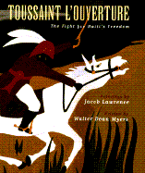 | Myers, Walter Dean. Toussaint L’Ouverture: The Fight for  Haiti’s Freedom. Paintings by Jacob Lawrence. New York: Simon & Schuster Books for Young Readers, 1996.  From the time he taught himself to read, Toussaint L’Ouverture believed that freedom was a basic human right. This is the story of a brave and determined man who was a true leader in the battle for Haiti’s independence.
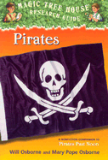 | Osborne, Will, and Mary Pope Osborne. Pirates. New York:  Random House, 2001.  What exactly is a Jolly Roger? Why is Davey Jone’s locker at the bottom of the ocean and not in school? Who were the most famous pirates? Join Jack and Annie as they dig up answers to all your questions!
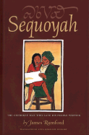 | Rumford, James. Sequoyah: The Cherokee Man Who Gave His  People Writing. Translated by Anna Sixkiller Huckaby. Boston: Houghton Mifflin Company, 2004.  Sequoyah was nobody famous. He was just a regular man with a really good idea. He invented a system of writing for his people- the Cherokee. This book tells his story in both English and Cherokee.
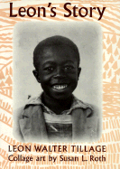 | Tillage, Leon Walter. Leon’s Story. Collage art by Susan L.  Roth. New York: Scholastic Inc., 1997.  Can you imagine looking in the mirror and cursing what you see? As a young boy, Leon Tillage would stare at himself in the mirror and curse his blackness. He grew up a sharecropper’s son in a small Jim Crow town in North Carolina. He knows what it means to have lived a hard life filled with struggle and fear and anger. He knows how to share and be optimistic and thankful. This is his story.



Poetry

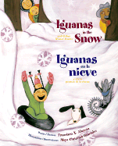 | Alarcón, Francisco X. Iguanas in the Snow and Other Winter  Poems/ Iguanas en la Nieve y Otros Poemas de Invierno. Illustrated by Maya Christina Gonzalez. San Francisco: Children’s Book Press, 2001.  Celebrate winter in San Francisco! This collection of bilingual poems will delight the senses of readers young and old, Spanish and English. ¡Ya llegó el invierno! Winter has arrived!
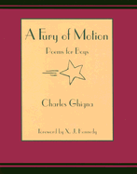 | Ghigna, Charles. Fury of Motion. Honesdale: Wordsong, 2003.  Do you think poetry is just for sissies? Well, guess what? This book may just change your mind. Inside it’s pages are poems specially designed with boys in mind. The poems are about a variety of topics such as sports, family, and growing up.
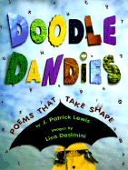 | Lewis, J. Patrick. Doodle Dandies: Poems That Take Shape.  Images by Lisa Desimini. New York: Antheneum Books for Young Readers, 1998.  Poetry takes on a new shape in this book, literally. Each poem is displayed in a shape and design that connects to the topic of the poem. Vibrant pictures and creative layouts blend with well crafted word choice to make this a book that all will enjoy.
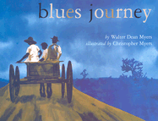 | Myers, Walter Dean. Blues Journey. Illustrated by Christopher  Myers. New York: Holiday House, 2003.  Felt like reading some poetry, to heal my heart and set me free  Felt like reading some poetry, to heal my heart and set me free  Painted pictures on my mind  Going on a blues journey  The blues can be sad and beautiful. This book will take you on an unforgettable journey. Get lost in the pictures and sing along to the blues. There is even a time line and glossary to help you understand blues terminology and history a little better.
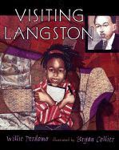 | Perdomo, Willie. Visiting Langston. Illustrated by Bryan  Collier. New York: Henry Holt and Company, 2002.  This is a beautiful picture book poem about a little girl and her father going to visit the home where the great poet Langston Hughes once lived.
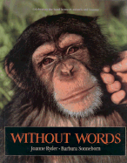 | Ryder, Joanne. Without Words. Illustrated by Barbara  Sonneborn. San Francisco: Sierra Club Books for Children, 1995.  Animal lovers- here is a book that celebrates you and the creatures that you love. This book pairs poetry and photography to highlight the special bond between animals and humans, the love and friendship that is shared without words.
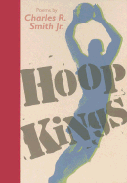 | Smith, Charles R., Jr. Hoop Kings. Cambridge: Candlewick Press,  2004.  Are you a die hard basketball fan? Do you love watching people like Allen Iverson, Tracy McGrady, and Shaq dominate on the court? Well, here is a book of poetry for you. Hoop Kings contains 12 slammin’ poems about basketballs greatest ballers.
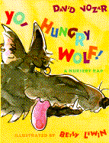 | Vozar, David. Yo, Hungry Wolf! A Nursery Rap. Illustrated by  Betsy Lewin. New York: Double Day Books for Young Readers, 1993.  There once was a wolf who was hungry and old-  Went after three piggies, but boy were they bold.  Met his match in Little Red.  “You can’t fool me” is what she said.  Then there’s the boy in the donut shop,  who lied and lied and lied a whole lot.  Since the whole town he’d been deceiving,  The boy cried wolf, but none would believe him.

