A Virtual Competition Model

In “Virtual Competition” Ezrachi and Stucke (2016) develop considerable possibilities for the future interaction of firms as they come to rely on artificial intelligence to make economic decisions. When it comes to cooperative behavior leading to monopoly pricing, they can only say that there is no way to tell what will happen. Their work includes no economic modeling, but this paper presents a model that suggests what is likely to happen. The model builds on the kinked curve literature. As is well known, the kinked curve has a followship and nonfollowship demand curves for a firm, the nonfollowship curve being far more elastic. Originally these curves were offered to explain rigid prices( Sweezy (1939), Hall and Hitch (1939) ), but later the presumption that price increases would not be followed was challenged (Peck (1961), Bashkar (1988) ). This view is based on the notion that price increases could be immediately rescinded if not followed. This notion is plausible if one is thinking about firm to firm sales that can’t be kept secret, but less convincing if one is thinking about retail sales. There prices have to be posted on shelf items and are not so quickly discovered or reversed. This is where modern technology and artificial intelligence enters. In a virtually competitive world firms are perfectly informed including instant awareness of all price changes or nonfollowship. What follows is intended to predict what perfectly informed profit maximizing artificial intelligence will do, not to explain what we observe human decision makers doing. The following approach suggests that dominant strategies will lead to equilibrium that may be close to the cartel level. If price increases are instantly rescindable, this may lead to cartel prices but this requires markets to be cooperative via some mechanism.

In Bashkar (1988) a sequential game is suggested that has a collusive equilibrium. This result hinges on instantly rescindable price increases that eventually lead to the cartel price maximum (or something lower of a Stackleberg type if firms are not identical). Here Bashkar’s linear example is used to illustrate that even if prices are not perfectly rescindable, price increases are dominant strategy perhaps up close to the cartel level. This depends on how close the goods are as substitutes; if the goods are close substitutes the followship demand is not very elastic and the cartel price will be not only high, but high relative to the noncooperative price equilibrium. If the goods are not close substitutes the followship demand is relatively elastic and the cartel price will be relatively low and close to the noncooperative price equilibrium. So it is possible in the kinked demand model that prices will be close to the cartel level even if price increases are not perfectly rescindable.

If the goods are close substitutes, rescindable prices become key in determining prices and artificial decision making will make rescindable prices more plausible. Cooperative decisions become more plausible, in the Bashkar (1988) mode. Bashkar (1988) leads to monopoly prices but the game assumed isn’t the only possibility. Human decision making historically has resulted in prices that exceed marginal cost, but it doesn’t seem that cartel levels are common.[1] Bashkar (1988) requires sufficiently dissimilar firm costs or demand for industries to fail to reach cartel pricing. And surely limit pricing has something to do with prices below cartel levels and judgements of this sort could be imposed on algorithmic processes. In this paper, first something of what we might expect from dominant strategies is developed. Then some discussion of might come from noncooperative interaction is offered. The Ezrachi and Stucke (2016) ascertain that there is no way to tell what artificial intelligence will lead to is improved, at least a little.

A Linear Model Depicted and Quantified

The Bashkar (1988) linear model:

1) Q1 = c –aP1 + bP2

2) Q2 = c – aP2 + bP1

Of course, the demands don’t have to be identical, but a must be greater than b to make the followship demand less than perfectly inelastic. Hence, if P1 = P2 = P, Qi = c –(a-b)P .

So for the followship demand, P = c/(a-b) – Q/(a-b) and if MC = d + eQ, then

3) =

[(2/(a-b) + e)Q0 -(c/(a-b) – d) - (1/(a-b) + e/2)(a-b)dP](a-b)dP

which is depicted by area A in Figure 1. Area A is the profit increase gained by cooperatively moving toward the cartel price. If however, firm 2 does not follow,

4) =

[(2/a + e)Q0 – ((c + bP2)/a –d) - (1/a + e/2)adP1 )]adP1

This is depicted by area B in Figure 1 and is a loss; the type of loss usually thought of when the kinked curve models originated. But area B does not have to be a loss. If the initial price is low enough so that MRnf is less than MC and the price increase is small enough, area B can be a gain, not a loss. With the initial price this low, a price increase is a dominant strategy, at least if it is small enough for area B to be a gain.

Figure 1

c/(a-b)

P1

MR f

D f

D n f

MC

ΔP1

A

B

(a-b)ΔP1

aΔP1

MR n f

Q1

(c+bP2)/a

The question remains, however, if firm 2 will follow. Given equations 1 and 2, equation 3 and area A applies to firm 2, but to measure the effect of nonfollowship on firm 2 equation 5 applies.

5) =

(P2 – d - eQ0 + (e/2)bdP1)bdP1

This is area C in Figure 2, which is small relative to area A if the initial price is low enough.

Figure 2

c/(a-b)

P2

MR f

D f

MC

A

(a-b)ΔP1

MR nf

Q2

C

bΔP1

Dominant Strategy Equilibriums

To give a feel for price levels that apply here, consider Table 1. Initially the following values are used; a=2, b=1, c=100, d=2 and e=1. The cooperative profit maximizing solution is elementary (Q = 32.6̅ = (c/(a-b)-d)/(2/(a-b)+e) and P = 67.3̅ = c/(a-b)-Q/(a-b)). And if Firm 2 follows price increases up to the point where Area C equals Area A this will appear as in Figure 3 where segment C (P2-MC) equals segment A (MC-MFf). If the price change is infinitely small, then Area C equals Area A because dP1(a-b) equals dP1b. If price rises to 60.79997, Q = 39.20003 and Segment C equals Q/a = 19.6 and Segment A = Q/(a-b) – Q/a =19.6. So firm 1 has a dominant strategy to increase price up to this level and firm 2 follows increases up to this level. This depicted in Figure 3.

Table 1[2]

Cartel Prices and Dominant Strategy Price Maximums for Three Cases

a b c d e P2 & P1 Q1 MRf MC MRnf if dP= .00005

2 1 100 2 1 67.33 32.67 34.67 34.67 51 A=-3.75E-09

2 1 100 2 1 60.80 39.20 21.60 41.2 41.2 A=C=.00098, B=-2.5E-09

3 1 150 2 1 56.75 36.5 38.5 38.5 44.5833 A=-1E-08

3 1 150 2 1 55.0908 39.8184 35.18 41.82 41.82 A=C=.00066, B=4.12E-08

1.5 1 75 2 1 90.8 29.6 31.6 31.6 71.0667 A=-1.56E09

1.5 1 75 2 1 69.268 40.366 -11.464 42.36 42.36 A=C=.001346, B=6.43E-07

For other values of a and b, a-b will not equal b, so the change in quantity for followship and nonfollowship will not be equal. As a consequence, P2-MC (segment C) will not equal MC-MFf (segment A) when area A equals area C (as dP approaches zero). Lines 3 and 4 of Table 1 quantifies such a situation when a = 3 and b = 1. The cartel price is 56.75 while the noncooperative price will only rise to 55.09. That’s as far a dominant strategies would take it; segment C is 55.09 – 41.82, which times a price change of .00005 is .00066 (area C, which can be replicated with equation 5). This is equal to segment A, 41.82 – 35.18, times 2 times the

Figure 3

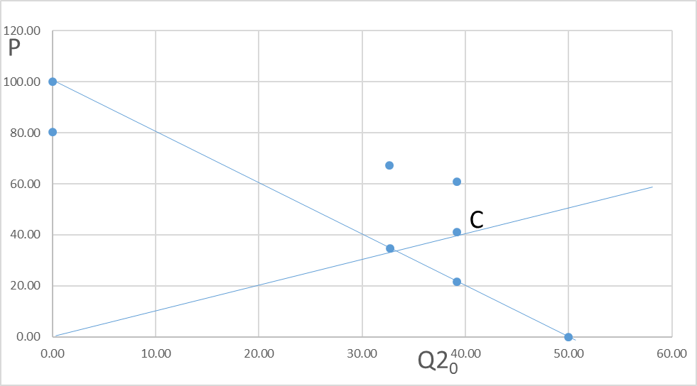

A

MC

MRnf

MRf

Dnf

Df

Q2

price change of .00005. This is area A and is also equal to .00066 and can be replicated with equation 3. Notice that segment C is twice segment A when the followship quantity change is twice as large.[3] This proportionality holds for all values of a and b.[4]

Notice when a is large relative to b, not close substitutes, that dominant strategy will take the price relatively close the cartel level (55.09/56.75=.971). Now consider closer substitutes, a = 1.5 and b = 1[5]. Lines 5 and 6 of Table 1 quantify such a situation. The cartel price is 90.8 while the noncooperative price might only rise to 69.268. That’s as far a dominant strategies would take it; segment C is 69.268 – 42.36, which times a price change of .00005 (b=1) is .0013451 (area C, which can be replicated with equation 5). This is equal to segment A, 42.36 + 11.464 which times .5 (a-b) of the price change of .00005 is also equal to .0013451. This is area A, which can be replicated with equation 3. Notice that segment C is half of segment A when the followship quantity change is half as large.[6]In this situation, the dominant strategy doesn’t take the price as close to the cartel level (69.27/90.8=.763). See Figure 5.

One objection that one might make to the analysis above is that it employs ridiculous small price changes and price levels are defined to excessive precision. This precision is required to exact proportionalities given above but if price changes are no smaller than a penny and prices are given with no more precision than that, the relationships illustrated above are closely approximated. For example, if a = 3 and b = 1 as in line 4 of Table 1, and dP = .01, price rises in dominant fashion to 55.09. Area B is -.00065 for dP = .01 and area A (.1324) is slightly smaller than area C. This is true if the approximation above is used (C =.01(P2-MC)=.1327) or equation 5 (.13275).

Noncooperative Interaction

Let it be emphasized that the equilibriums found so far will occur without price increases being rescindable. The price increases increase profit for the leader with or without followship and firm 2 does follow because it is more profitable. With rescindable price increases, however, firm 2, only gets the larger profit, C, for a moment or in Bashkar (1988), not at all. Bashkar presumes that prices have to be widely known before purchase, but in a world of artificial intelligence, presumably a price increase would be immediately in place and shift consumption for at least a short period of time. (Presumably consumers will be able to program consumption to buy at least cost. Signaling price changes is discussed below.) So noncooperative gamesmanship may be complicated. Table 2 is offered to illustrate how a follower might make better profit than a leader.

As shown in Table 1, the greatest potential for followship to lead to high prices occurs when the goods are close substitutes, a is nearly equal to b. In this case, the quantity demanded is almost fixed at c, each firm’s lost demand from a price increase is almost entirely offset by gains that come from the other firm’s higher price. As given in Table 1, when a = 1.5 and b = 1, the cartel price is 90.8 and price increases cease to be a dominant strategy at a price 69.3. At prices above 69.3, the follower does better not following, but only until the leader rescinds the increase. Arguably, when the gain from not following is not much better (see Table 2), the follower will follow to avoid time when the price is not higher. The leader may try repeatedly to get the higher price, especially if the time that it allows for nonfollowship is very short and if the loss from nonfollowship (area B) is small (Table 2). But if the leader tries to lead in this manner then the follower has more gains noncooperatively. Eventually, the leader may stop or the follower may finally follow to avoid that. As Ezrachi and Stucke (2016) contend, there is no way to know what will happen.

But it seems plausible that with artificial intelligence, prices will eventually climb above the dominant strategy level, since profit is higher that way. Will the cartel level be reached? Near the cartel level the gain from nonfollowship, C, will be large and the gain from following, A, will be small (Table 2). And the leader’s loss from nonfollowship, B, will be large. Kreps et al. (1982) suggest that firms can escape our prisoner’s dilemma if information is incomplete about each of their “types.” If they can establish reputations as “tit for tat,” rational interaction leads to highly collusive interaction. But as Table 2 shows, the temptation to not follow price increases (C), is large as the firms near the cartel level. And the profit lost when not followed is large too (B).

Of course, prices don’t have to be rescindable if signaling can generate cooperation. Ezrachi and Stucke document cases where firms have already used artificial intelligence to “steer” or signal price changes.[7] There are doubtless many ways artificial intelligence can signal a price increase without actually confronting customers with it and firm 2 can signal agreement which would lead to a simultaneous price increase. If the understanding were violated, the increase could be quickly rescinded minimizing the area B loss. But then we are back to the Table 2 situation. And the Ezrachi and Stucke show that this sort of signaling has been found to be collusive.

Table 2

Profit Effects When Goods are Fairly Close Substitutes

(a = 1.5, b = 1, c =75 and dP = .01 (cartel price = 90.8, dom strat max = 69.27))

P Area A Area B Area C

70 0.27 -0.02 0.28

90 0.0099 -0.57 0.58

Conclusion

Artificial intelligence is presumed to have nearly perfect information about market conditions and competitors prices and to be able to rescind price increases almost instantly. Given these conditions, this paper suggests that dominate strategies may well lead to prices near the cartel level and that to the degree that market conditions leave a prisoner’s dilemma, that firms will likely get close to the cartel position or a least as high as limit pricing allows.

References

Bhaskar, V. 1988. "The Kinked Demand Curve: A Game-Theoretic Approach" *International Journal of Industrial Organization* Vol. 6, pp. 373-384.

Ezrachi, Ariel and Stucke, Maurice E. 2016. *Virtual Competition.* Harvard University Press

Fudenberg, Drew and Tirole, Jean. 1991. *Game Theory*. MIT Press.

Hall, R.L. and C.J. Hitch. 1939. “Price Theory and Business Behaviour” *Oxford Economic Papers 2, 12-45.*

Kreps, D., P. Milogram, J. Roberts and R. Wilson. 1982. “Rational Cooperation in the Finitely Repeated Prisoner’s Dilemma” *Journal of Economic Theory* 27: 245-252, 486-502.

Masson, R. and Shaanan, J. 1984. “Social Costs of Oligopoly and the Value of Competition” *The Economic Journal* 94, 520-535.

Peck, M. 1961. *Competition in the Aluminium Industry: 1945-58.* Harvard University Press, Cambridge.

[Sweezy, P.](https://en.wikipedia.org/wiki/Paul_Sweezy) 1939. "Demand Under Conditions of Oligopoly" *The Journal of Political Economy* Vol. 47, pp. 568-573.

Figure 4

c/(a-b)

P2

MR f

D f

MC

A

MR nf

Q2

C

(c + bP1)/a

D nf

P20

Q20

Figure 5

c/(a-b)

P2

MR f

D f

MC

A

MR nf

Q2

C

(c + bP1)/a

D nf

P20

Q20

Figure 3

c/(a-b)

P2

MR f

D f

MC

A

MR nf

Q2

C

(c + bP1)/a

D nf

P20

Q20

1. Masson and Shaanan (1984) estimate market power effects in 37 industries taking limit pricing directly into account.
2. All values in this table can be confirmed in spreadsheet online at­­­___________.
3. This is illustrated online at __________________.
4. It is worth noting that these proportionalities hold even if demand is nonlinear. Nonlinearity affects the size of price effect on quantity, so a larger effect will decrease the size of segment A relative to segment

   C. But for infinitely small price changes, price increases cease to be a dominant strategy when segments C and A are such that areas A and C are equal.
5. They are better substitutes in this model in the sense that when a = b, a rise in both prices will cause the decrease in sales in market 1 to be completely offset by a shift in consumption from market 2. In this extreme case demand is perfectly inelastic a quantity c. So to the degree that a is near to b, the cartel price inflates and is not near the dominant strategy maximum.
6. This is illustrated online at __________________.
7. In game theory signaling has specific usage where one firm has “private information” and moves first. The other firm observes the move, but does not know the private information. Firms in this paper firms have the same information. See Fudenberg and Tirole (1991), p 321. See Ezrachi and Stucke (2016), p 39 for discussion of steering or signaling.